bdubord@ncajets.org bdubord.weebly.com
SECOND GRADE NEWS April 27, 2018
Notes: Thank you to all who brought snacks this week! We are well stocked.

Reading: This week Unit 5 Test Record Sheets will be going home. Please take time to look over and let me know if you have any questions. I was very impressed with the improvement in writing scores as a class. Students are really making an effort to restate questions and include examples and details. Next week we will be reading a non-fiction story about the history of our flag.

Spelling: Next week we will be focusing on endings –ing and –ed, so there will be no advanced list as we focus on ways endings change a word. There will be 10 points from the contract due by Friday, April 27th. Words will be: cried, crying, hiked, hiking, liked, liking, planned, planning, skipped, skipping, tried, trying

Math: This week we started learning to tell time to the nearest 5 minutes. Students are doing very well overall. This can be a very difficult skill for students to master, so we will continue this into next week.

Language/Writing: Next week we will continue practicing to edit sentences for spelling, capitals, and punctuation. We will work on our Opinion pieces on our favorite seasons. Surprisingly, no one has picked winter so far.

Social Studies/Science: Next week we will finish our unit on exploring matter with some activities where students will be required to support a prediction to a science question based on what they have learned so far. See pictures below from activities this week.
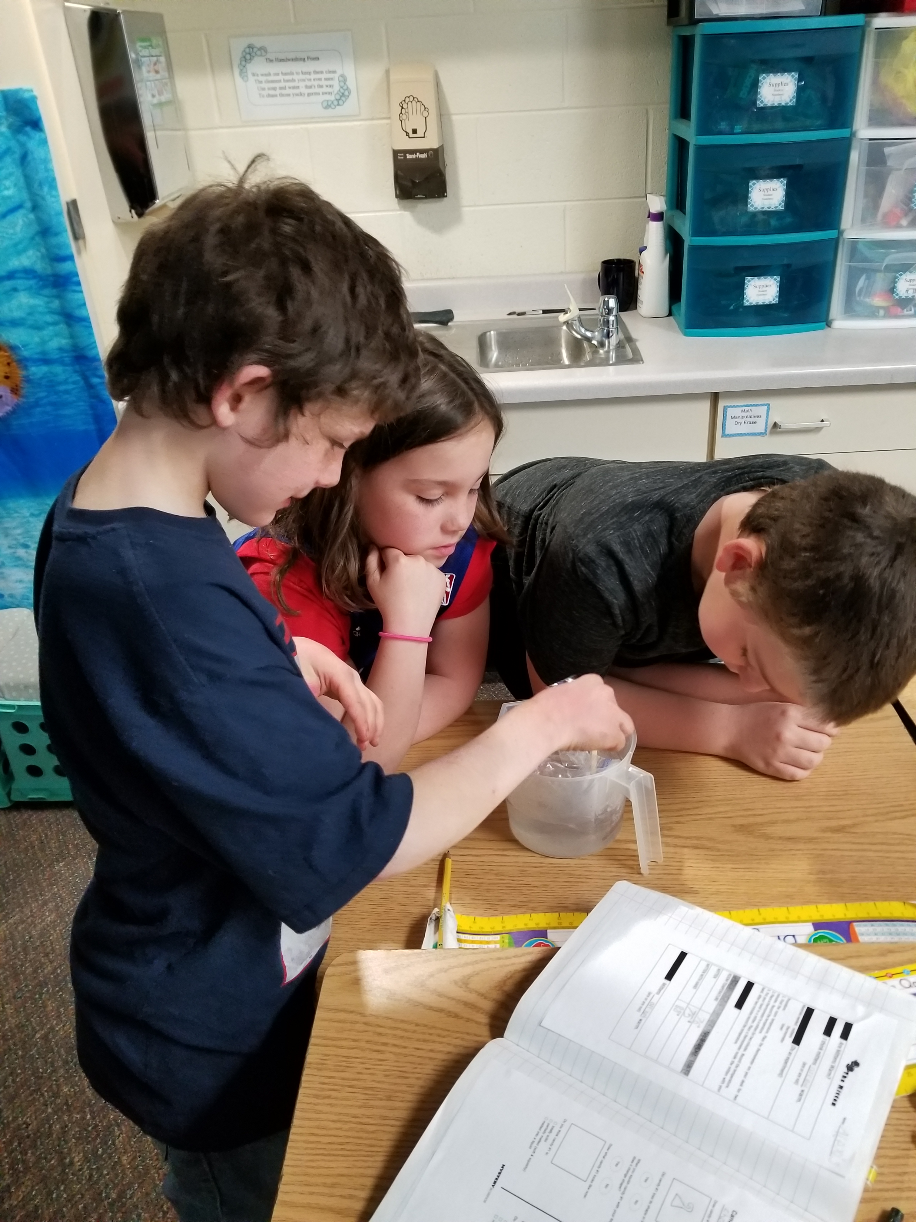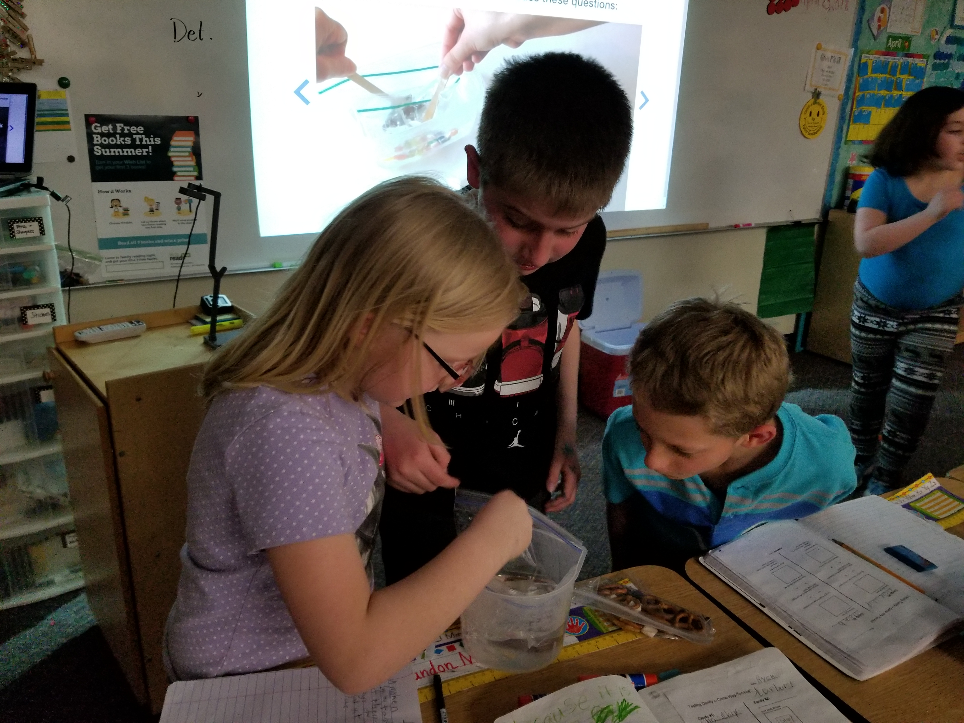

Name:

Name: ____________________________________

Upcoming Dates:
May 22nd: Kids Read Now Family Reading Night 4pm-5pm at the Elementary School

May 28th- No School- Memorial Day

Grandparent’s Day
Thanks to all who attended! Our class was so excited to have visitors. Students were very welcoming and it made for a great day.

Our Haiku Poetry
Celebration!
Throughout the year we worked on making good choices as a class. Each time someone (besides me!) complimented our class as a whole (at art, hallway, etc.), we added it to our compliment board. This week, we were able to earn our last compliment! We will hold a class celebration next week to celebrate meeting this goal!

