bdubord@ncajets.org bdubord.weebly.com
SECOND GRADE NEWS December 1, 2017
Upcoming Dates:
December:
4th- NCAP meeting @ 6:00
12th- Bookmobile
12th- Santa’s Secret Shop Shopping Day
14th- JETS Day: Wear NCA colors
20th- Christmas Program 1:00/6:00
Christmas Break: Dec 25-Jan 1

Take note of the events coming up in December. It will be a busy month! Please remember to turn in your child’s book it log for the month of November if they have been reading. A December calendar log is coming home today. Please know my goal for this program is to reward/encourage students to read at home. I do not expect students to set a timer when reading or even get exactly 20 minutes every time. I do not want the book log to have the opposite effect and become a chore that discourages reading! If your child is reading at home, have them color in the days they are reading. If your child is reading (or listening to someone read!) 10-20 minutes most nights a week, make sure they turn it in!

Reading: Next week we will be reading a fiction story called Pearl and Walter. We will be reviewing the story elements of character, setting, and plot. This week we had a fun time working on reading and writing poetry. See some of our haikus below! (5, 7, 5 syllable patterns)

Spelling:: There will be 10 points from contract due on Friday. We will be starting Unit 3 words next week. The words and spelling city links are posted on my website. We will be working on long e words with patterns y, ea, and ee. See note at right on advanced lists starting Monday. Regular list words will be: read, wheel, feel, easy, leave, windy, deep, sleep, seat, teeth, party, team, wreath, eagle, season

Math: This week we started with concepts of regrouping. We used a variety of different hands-on strategies, and students are building an understanding of the concept. Next week, we will learn the standard method of regrouping.

Language/Writing: We started with possessive nouns, which can be very difficult. If students cannot remember the difference between a singular and plural noun, it is a difficult standard. One thing that is common is that many students start putting an apostrophe on any words that have an “s” in them. We are working on knowing when to use them too.

Science: This week, we started our next STEM challenge. More details will follow next week.

Name: ____________________________________

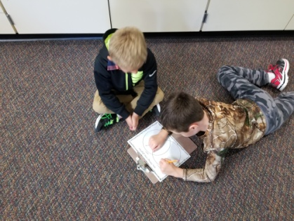
Advanced Spelling Lists
Next week, we will start advanced spelling lists. We will take a pretest on Monday. Any student who scores less than 2 words incorrectly has the opportunity to have an advanced list that fits the same patterns. They will practice this list in the classroom, as well as with their contract. On Friday, they will be tested on the advanced list. (In the case of a very low score, I would use your child’s pretest score instead. So, the challenge list can’t HURT their score.) Each week, students have to pass the pretest in order to get the advanced list that week. The one problem with this list is there are no Spelling City links set up. So, your child would have to type their words to get on Spelling City and the games are limited.

Our Haiku Poetry
Nature
By: Maddy
The birds are singing,
There is a beautiful sight.
It is a good day.

Deer
By: Athena
I like to watch deer.
I see them jump way up high.
They are so pretty.

Cheetahs
By: Alexis
Cheetahs run quickly.
Cheetahs hunt for predators.
Cheetahs come and go.
Bears
By: Miley
Bears are really mean.
Bears hibernate in the Fall.
Bears have cubs sometimes.

Winter
By: Bella
Winter is coming.
Snow is falling on my head,
I make snow angels.

Winter
By: Myles
Watch out for snowbanks!
The trees are losing leaves now.
Birds are flying south.

