bdubord@ncajets.org bdubord.weebly.com
SECOND GRADE NEWS December 14, 2018
Upcoming Dates:
12/17- Mrs. Dubord out- Sub teacher
12/18- Santa’s Secret Workshop- Please send in labeled envelope with money if you would like your child to shop.
12/19- Christmas Program- 6:00 at the high school Dress Rehearsal- 1:00 at the high school*** If you will be picking up your child after, please send a note or let me know on Remind BEFORE the program.
12/20- Classroom Celebration- See note below! Thanks to all who have donated items for the pantry so far or volunteered to bring a treat for the party.
December 24-Jan 1- Christmas Break
There will be no behavior reports next week due to it being a not-so-normal week!

Reading: Next week we will be taking a break from our Reading Series and reviewing some standards using Christmas stories!

Spelling: There will be NO contract this week. I know it is a busy time, especially with the Christmas program. Instead of a new list, I will be reviewing former spelling rules and the skill of ABC order.

Math: This week we continued working on addition with regrouping, and the different strategies we learned this week. We took our Unit 5 test on Thursday. We also moved into a review of subtraction skills. Next week we will spend the week practicing some of these different skills, including adding distances between two numbers to subtract 2-digit numbers. (This skill helps push students toward being able to solve problems using mental math.)

Language/Writing: We have been continuing our Explanatory Writing by creating a writing piece for the hall. Next week, we will finish up our Possessive Noun unit.

Science: Next week we will be completing a Christmas themed Science Challenge.

(Below: Students participate in a Christmas Drawing Conclusions Rotation)
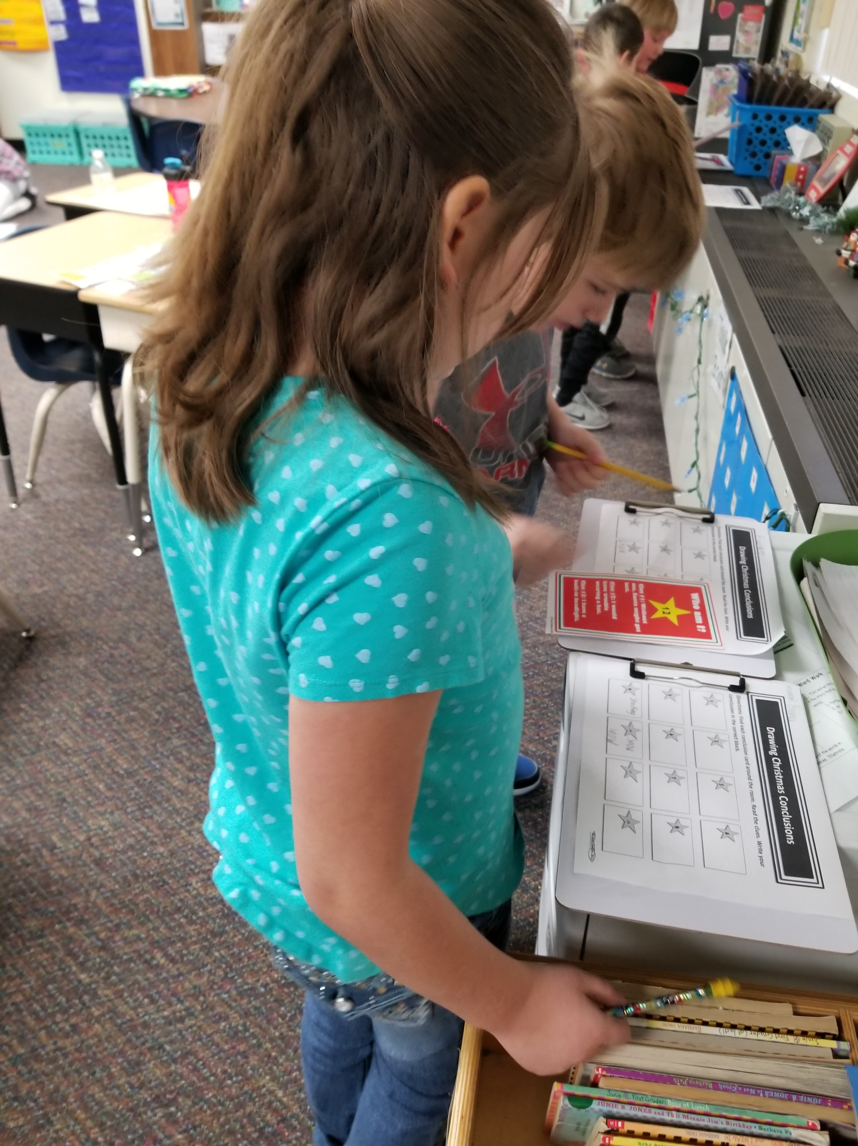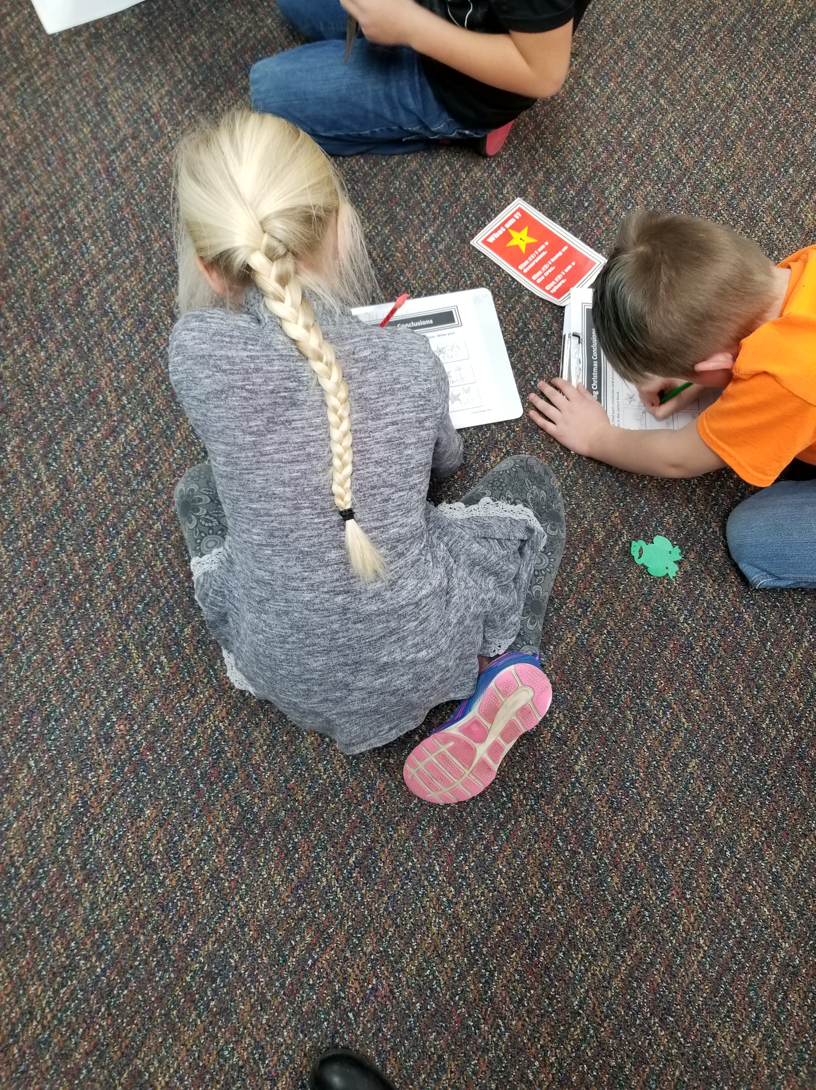

Name: ____________________________________

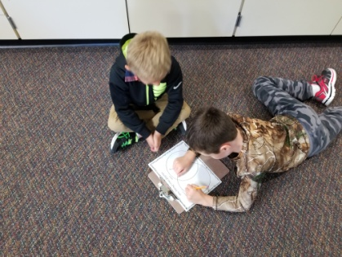

Christmas Celebration- Thursday, Dec 20th
Schedule- Right after WIN Groups (12:50) we will have our classroom treats. If you would like to send a treat in with your child, please let me know to make sure we have enough! We have 20 students. Students then will go outside for Recess (at 1:20) After recess, we will be walking over our items that we have collected for the food pantry around 1:45. Please let me know if you would like to come with to deliver items to the pantry!

Instead of having Classroom gift exchanges this year, K-2 grades are going to be learning about giving to others! The lower el. will be collecting items for a local food pantry. Students are not required to bring in any items in order to participate, but instead of spending $5 on a gift exchange item, we encourage your child to select an item (or a few!) to donate to those in need. Example items include: canned/non-perishable food items, shampoo, hand soap, toothpaste, toothbrushes, deodorant, toilet paper, Kleenex, etc.

Our Haiku Poetry

