bdubord@ncajets.org bdubord.weebly.com
SECOND GRADE NEWS December 15, 2017
Upcoming Dates:
December:
20th- Christmas Program 1:00/6:00
21st- Christmas Party@ 2:00
Christmas Break: Dec 25-Jan 1

This week, Unit 2 test score sheets are going home. I was very impressed with the scores overall! We also took our STAR Math and Reading tests this week, and it was great to see the progress students have made.

Reading: Next week we will be taking a break from our Reading Series and reviewing some standards using Christmas stories.

Spelling: There will be NO contract this week. I know it is a busy time, especially with the Christmas program. We will be having a special Christmas list made up of words with sounds that should be a review.

Math: This week we continued working on addition with regrouping, and the different strategies we learned this week. We took our Unit 5 test on Friday. We also moved into a review of subtraction skills. Next week we will spend the week practicing some of these different skills, including adding distances between two numbers to subtract 2-digit numbers. (This skill helps push students toward being able to solve problems using mental math.)

Language/Writing: Before break, we will do a quick review of Verbs, and move into verb types after break.

Science: Next week we will be completing a Christmas themed Science Challenge.

Name: ____________________________________

With the colder weather, please make sure your child is dressed for outdoor recess! Snowpants, hats, mittens, jacket)

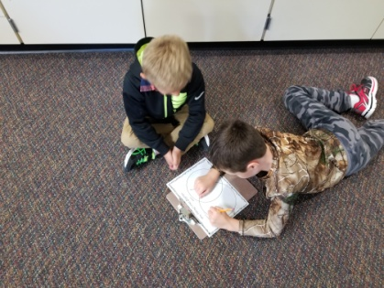
Christmas Party
The lower elementary Christmas parties will be held on Thursday, December 21st. Our party will start after recess, around 2:00. We will be having treats, and we will also have a gift exchange. For the gift exchange, girls can bring in a wrapped gift labeled “To Girl”, and boys can bring in a wrapped gift labeled “To Boy”. Students will then randomly choose a gift to open, so every student in the class will go home with a surprise gift. The suggested amount to spend is $5.00. Please let me know if you do not want your child to participate in the gift exchange. If possible, please have the gift in before Thursday. If you would like to bring in a treat for the party, feel free to let me know what you will be bringing to ensure we have enough variety. So far we have one sweet treat and drinks.

Our Haiku Poetry
December 20th- Christmas Program 1:00 & 6:00- If your child will be picked up after the 1:00 performance instead of returning to school, please send a note with them to school that morning, or contact me via email or Remind. After the program can be very chaotic, and this helps me to plan!

No behavior report- Substitute Teacher

