bdubord@ncajets.org bdubord.weebly.com
SECOND GRADE NEWS January 5, 2018
Upcoming Dates:
January:
9th- MOBY- Have books here by the 8th.
18th- Student Dismissal at 11:50 (Staff PD)
19th- Student Dismissal at 11:50 (End of First Semester)

I hope you all had a great Christmas break!

Reading: We will be reading Rosa and Blanca and focusing on theme and plot. We will also use context clues to figure out the meanings of some Spanish words in our story. This week we read a variety of Anansi the Spider stories, and the students enjoyed reading about his “tricks”.

Spelling: There will be 10 points from the Contract due. We will be studying words with long i sounds. There will be a pretest on Monday, so students getting less than 2 wrong will have the choice for the advanced list. Regular words will be: find, child, sky, bright, wild, fly, right, flight, spider, cry, blind, myself

Math: This week we worked on subtraction strategies, and brought in subtraction with regrouping. We started with using base ten blocks, so students understand the concept of what regrouping a ten means, and why it works. Next week, we will move into the standard algorithm.

Language/Writing: This week, we started talking about Narrative Writing. We focused on writing about New Year’s Goals and things that we wanted to accomplish. Students also started the week by making a graphic organizer of their “Proud Moments” from 2018. We discussed how important it was to be proud of our successes.

Social Studies/Science: Next week we will be talking about processes that change Earth’s surface, such as volcanoes, earthquakes, erosion and weathering. We will learn about the processes next week, and then do some hands-on activities the weeks that follow.

Name: ________________________________________

Name: ____________________________________

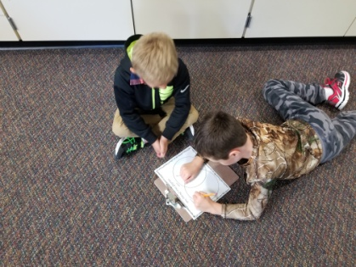
Below are some pictures of our class doing our Santa’s Sleigh Challenge before break. To see more pictures and information, check out the Class Activities Tab on my Weebly: bdubord.weebly.com

(One of the sleighs got caught on the strings hanging from the ceiling, so we decided it had the best “hang time”.)

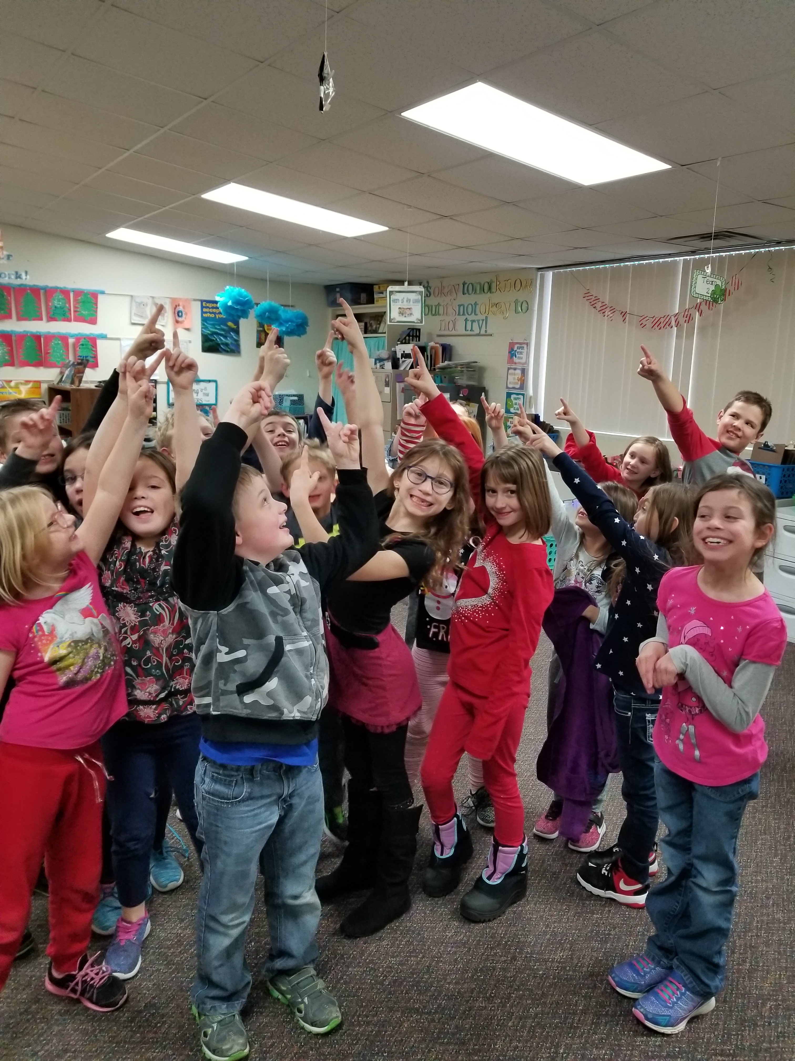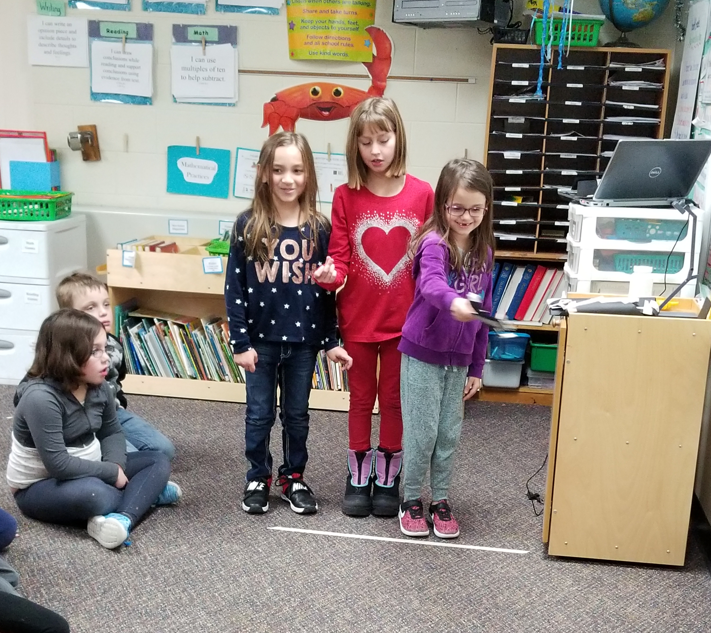

h

Our Haiku Poetry

No School

