[bdubord@ncajets.org](mailto:bdubord@ncajets.org) Sorry about the black and white! Color is not available at this time!

SECOND GRADE NEWS November 10, 2017

**Upcoming Dates:**

**November:**

14- MOBY here- have books in by Monday

14- **Book Orders Due!**

15- No School- Deer Day

20- 1st Quarter Awards Ceremony 2:15

22- Early Dismissal @11:50- Thanksgiving Break- 11/23 & 11/24

**THANK you to all who came to conferences. It was great getting to see so many of you. I know some of us talked about things you can do at home. One of the things was Readworks: a site where I can assign reading passages for a student to read and answer questions. Another free website is Bookflix- a Scholastic site where stories are animated and can be read aloud to students. (Reading on these sites can even count toward minutes on the Pizza Hut Reading Log!) See info for these sites below.**

**Reading:** Next week we begin a fun standard based on character’s points of view. We practice showing a character’s feelings based on speaking in different voices. We also discuss how a character changes from the beginning to the end of a story. We will be reading the story *Breman Town Musicians.*

**Spelling::** There will be 10 points from contract due on Friday. Next week’s words will be plurals. We have been practicing this skill in language too. Words will be note, notes, lunch, lunches, story, stories, tune, tunes, switch, switches, baby, babies. Challenge: crumbs, supplies, centuries

**Math:** Next week we will end Unit 4. Unit 4 was very difficult, as it required students to stop and think about “is more than” and numbers that “make sense.” Unit 5 starts an introduction into place value. I often feel this Unit helps a lot of other concepts “click”, as it helps to build an understanding of numbers and number sense.

**Language/Writing:** Next week we will be working on Collective Nouns. Collective nouns are special nouns used for groups of things: Ex- a pride of lions, a bouquet of flowers, etc. For writing, we will continue discussing opinion writing and talking about things we are thankful for.

**Science:** We spent a majority of our Quarter 1 on Social Studies standards. This quarter, we will focus mainly on Science. Much of our Science is hands-on and follows the STEM design (Science, Technology, Engineering, and Math) Next week we will start with learning about STEM, as well as the EDP (Engineering Design Process.) Throughout the year, students will work in groups to complete challenges that require them to use and apply their knowledge of different math and science concepts.

With the COLD weather, please make sure your child is dressed appropriately for outdoor recess! (Hat, mittens, boots, snow pants, etc.)

Name: ____________________________________

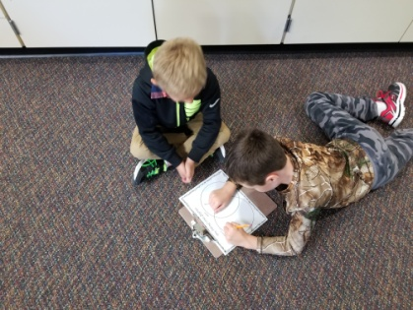

This week, students received a lesson on fire safety by Les Srnka. He comes monthly throughout the year to go over various Safety rules.

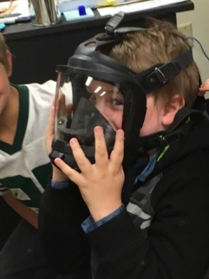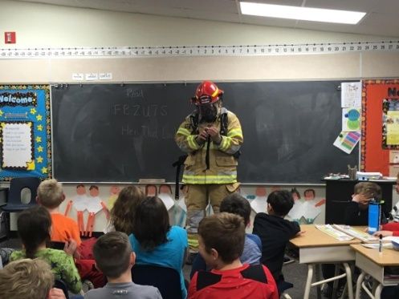

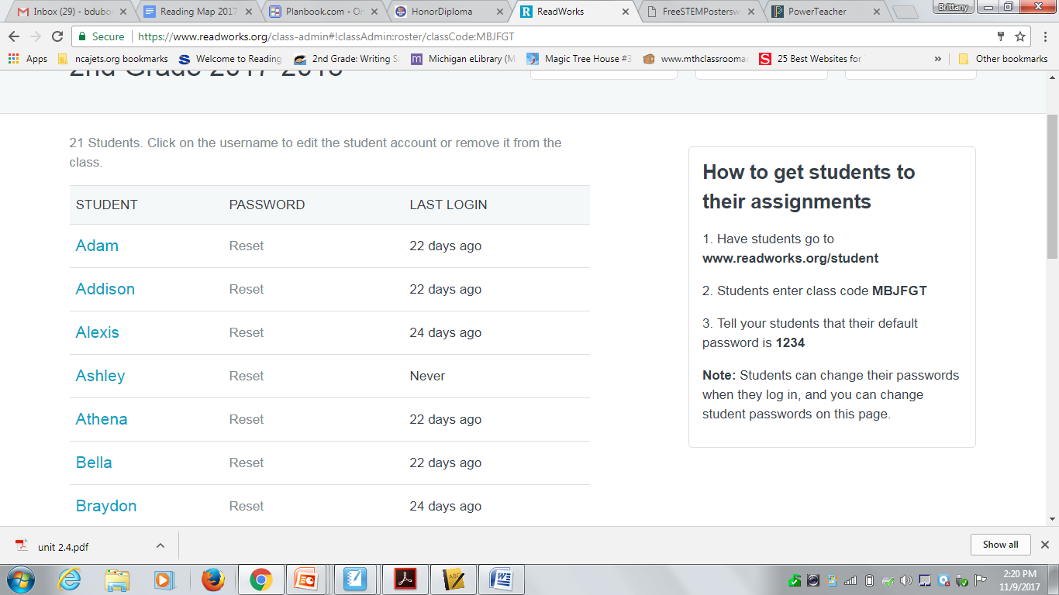

**Readworks:**

**Bookflix: You must go through the MI elibrary to get free access.**

<http://kids.mel.org/Storytime> Click "Scholastic Bookflix".

**I will post these links on my website bdubord.weebly.com too!**

