[bdubord@ncajets.org](mailto:bdubord@ncajets.org) bdubord.weebly.com

SECOND GRADE NEWS November 17, 2017

**Upcoming Dates:**

**November:**

20- 1st Quarter Awards Ceremony 2:15

22- Early Dismissal @11:50- Thanksgiving Break- 11/23 & 11/24

Nov 27-Dec 1: Smiles on Wheels here- Please return form that went home even if it is a “no”.

**December:**

20th- Christmas Program 1:00/6:00

**There will be NO newsletter next week due to Thanksgiving. No behavior reports will go home, but I will contact you if there are any concerns. Spelling Homework on next week’s words will be due (10 points from Contract) Thursday, November 30th. Students will have 2 weeks to complete due to the shortened Thanksgiving week.**

**Monday is our First Quarter Awards Ceremony at 2:15. Parents are invited to attend and support our students. There are so many who continually work hard and make great choices.**

**Reading:** Next week we will be reading a story called *A Turkey for Thanksgiving.* The week after Thanksgiving will be Unit 2 Review week. We will be reviewing skills we have learned, as well as focusing on poetry. We will take Unit 2 Test on Dec. 1st.

**Spelling::** There will be 10 points from contract due on Thursday, Nov. 30th. We will spend 2 weeks on these words, since the week after break is a Review Week. 1.5 words will be long a. Words will tail, main, wait, say, away, play, raise, brain, paint, stay, today, tray, holiday, daily, raisin

**Math:** This week we started Unit 5 on place value. This will continue after Thanksgiving break as well. We took our test on Unit 4. Students are still making many simple mistakes due to rushing and not “thinking” about an answer. (Ex: 5-2=7) This is something we discuss daily. Tests are not going home this week, as we will be reviewing them together.

**Language/Writing:** Next week we will be writing informative paragraphs on the Mayflower and creating a model to go with it. After break, we will be working on writing different poems to fit with our Reading Unit. For Language, we will start possessive nouns.

**Science:** This week we discussed STEM (Science, Technology, Engineering, and Math) and the EDP (Engineering Design Process). Students worked in groups to practice problem solving. They had to “Save Fred” (a gummy worm who flipped his boat upside down) by putting his “life preserver” on using only 4 paper clips. They were not allowed to touch Fred or his boat and life saver with their hands. It was fun seeing the problem solving in action. Students thought the task would be impossible, but realized that by talking it through with their partner, they could figure it out and Save Fred. See pictures at right.

Name: ____________________________________

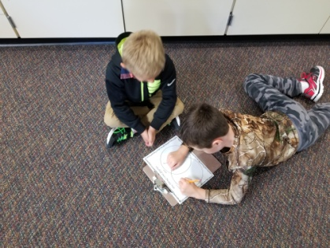

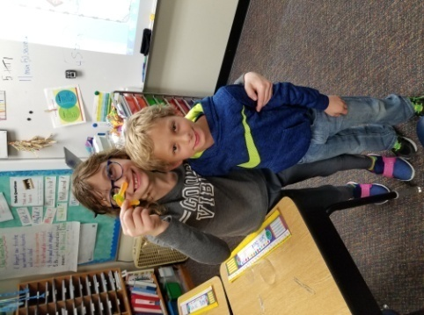

The First Team to Save Fred!

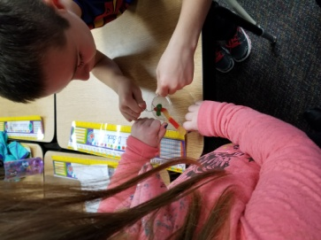

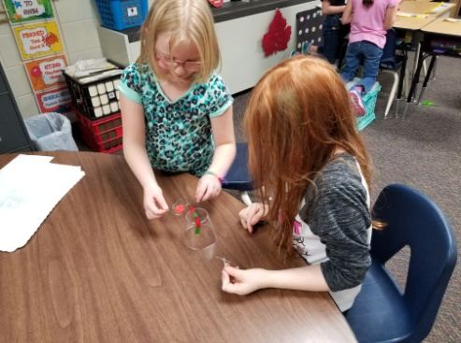

**No Report-**

**No School!**