bdubord@ncajets.org http://bdubord.weebly.com
SECOND GRADE NEWS November 3, 2017

Upcoming Dates:
November:
3- End of 1st Quarter
5- Don’t forget to set your clocks back!
8- Parent Teacher Conferences- 11:50 Dismissal
14- MOBY here- have books in by Monday
15- No School- Deer Day
22- Early Dismissal @11:50- Thanksgiving Break- 11/23 & 11/24
Weekly Notes: I have updated my class website: bdubord.weebly.com with a few of the Halloween pictures if you would like to see them.
Thank you for all who returned conference forms. Please see note coming home regarding your time. I look forward to seeing you!
~ Thanks to all who supported our Foster Grandparents by sending in money for wristbands. They will still be collecting donations next week as well.

Reading: We continued to work on how characters respond to an event or challenge. Students participated in discussion and we related this skill to a variety of stories. Next week, we will move back to fables and folktales. We will be reading the story Turtle’s Race with Beaver. This is a fun story that students typically love reading. We will discuss the lesson learned in this story, as well as other fables and folktales.

Spelling:: There will be 10 points from contract due on Friday. Next week’s words will be r-controlled vowels with er, ur, and ir. Words will be her, person, nurse, dirt, turn, birth, serve, curb, curl, skirt, purse, turtle, hamburger, surface, perfect

Math: This week, we started Unit 4. Unit 4 focuses on some pretty difficult skills. Students were required to fill in statements: ____ is _____ more than _____ and create equations to match. This is a multi-step process, as students are required to think about where each number must go in the equation based on the placement in the sentence. We also worked on fact families and making different equations (10-6=4, 4+6=10, etc.) Next week we will expand on these skills and bring in word problems.

Language/Writing: Students had a great time completing our pumpkin writing competition with Mrs. Veeser’s class! Students voted for their favorite in each category based on the pumpkin and the opinion writing. From our class, Maddy won the category “friendliest.” Next week, we will be reviewing writing friendly letters and including the commas correctly, as well as moving into irregular plural nouns. (Ex: child- children)

Science/Social Studies: Next week, we will continue learning about symbols of our country, as well as learning about the importance of Veteran’s Day.

Name:

Name: ____________________________________

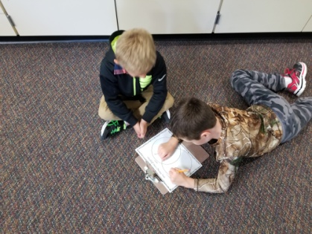
Halloween
Thank you to ALL who made this day great by attending or bringing in a snack. Students had a great time trick-or-treating at Whispering Pines and Pinecrest, and were very respectful and kind. (See more pictures on my 2nd Grade Weebly!)

