bdubord@ncajets.org http://bdubord.weebly.com
SECOND GRADE NEWS October 20, 2017

Upcoming Dates:
October 26- Mrs. Dubord at ISD for training
October 31- Halloween
12:30- Our class events start! 2:00- Parade
November 8- Parent Teacher Conferences- Info coming soon
November 15- No School- Deer Day
Weekly Notes: As a note, as students finish work throughout the week, they put it in their mailboxes. At the end of the day, I have been giving them the choice to take it home in their nightly folders, but many prefer to leave it and take it all on Friday. If you would like them to take their work nightly so you do not have a huge stack on Friday, please let me know.

Reading: This week we took our Unit 1 tests. Watch for score sheets going home within the next couple of weeks. Students enjoyed reading different fables throughout the week. Next week we will be switching into Unit 2, starting with a fiction story called Tara and Tiree. We will be focusing on how characters respond to events and asking questions while reading.

Spelling: Spelling: There will be 10 points from contract due on Friday. Reminder: I encourage students if they do not have time to do them throughout the week at home to get it done in class throughout the week. So, students should be completing this weekly! Next week’s words will be r-controlled vowels –ar, -or, and –ore. (part, hard, born, horse, before, more, smart, farm, porch, corn, chore, score
Challenge Words: cardinal, therefore, morning

Math: Watch for Unit 2 tests going home. Overall, students did great! Many mistakes that were made were simple “miscounting” errors, so we have been discussing the importance of carefully doing work. We will finish Unit 3 next week, continuing our work on missing addends by involving word problems.

Language/Writing: This week, we wrote our favorite parts about fall, and made a craft to go with our writing in the hallway. Check out our work if you are in our hallway! Next week we will be doing some fun writing involving describing a Jack-O-Lantern. In Language, we will be moving into our nouns standards, starting with a review of singular/plural, etc.

Science/Social Studies: Next week our goal is to
finish creating our landform models and present
them to the class! (At right) Students work on
researching for their project.

Name: ____________________________________

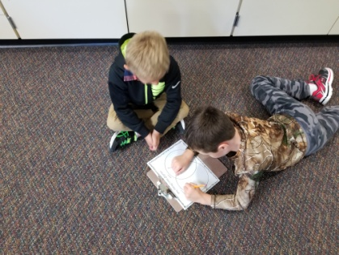
Halloween
In the afternoon, we get the opportunity to go trick-or-treating at Whispering Pines/Pinecrest with the 3rd Grade class. Busses will leave around 12:30, so students will be getting dressed in their costumes at 12:00. When we get back, we will prepare for the parade at 2:00 with our party after the parade. If you plan on going to Pinecrest with us, please meet us there at 1:00. So far, we have drinks and one person signed up to bring treats for the party. If possible, please let me know if you plan on bringing food or a treat, so I know if we will have enough for our party!

