bdubord@ncajets.org http://bdubord.weebly.com
SECOND GRADE NEWS October 26, 2018

Upcoming Dates:
October 31- Halloween
Parade at 2:45
Nov. 2- End of Quarter 1
Nov. 7- Parent Teacher Conferences- 12:00 Dismissal
Nov 15/16- No School- Deer Day

Specials Next Week:
Monday- Library
Friday- Music
Weekly Notes: Reminder: Please return your Book-It Logs if your child read at home in October. I am sending home a new log for the Month of November. I am trying a different type of log, but if you find the calendar/minute tracker easier, let me know and I will send!
~This week Unit 1 Reading Test score reports are going home. Please take a minute to look over. Remember, this is a brand new test where students are required to read the whole thing on their own. I will spend parts of next week working in flexible small groups to go over areas that were a struggle.
~Please see the note going home regarding conferences sign up!
~Next week is our last week to donate change for our Foster Grandparent Spare Change Drive. Thanks SO much to all who have donated!

Reading: This week we worked on discussing how characters react to a challenge. We also introduced not just answering questions, but asking them as well. This is a skill we continue to work on throughout the year. Next week, we will be reading a fiction story called Ronald Morgan Goes to Bat. We will be practicing the skills we worked on this week.

Spelling:: There will be 10 points from contract due on Friday. Next week’s words will be contractions. We focus on the meaning of the words, as well as the spelling. To be correct, students must capitalize the "I" in I'll and I'm. Words are: I'll wasn't it's he's I'm didn't who's she's we'll isn't hasn't hadn't Challenge Words: wouldn't shouldn't where's

Math: Next week, we will start with our Unit 3 test. Students have done very well with the different strategies on finding missing addends. Still, a struggle I am noticing is students missing a number in counting or miscounting. We discuss making sure to not rush through our tests and to check our work.

Language/Writing: This week we typed and finished our Fall Writing. Look for it in our hallway! For Language, we started reviewing nouns. This will continue next week with singular and plural nouns.

Science/Social Studies: Next week we will continue working on landforms. We will be doing some hands-on activities.

Name:

Name: ____________________________________

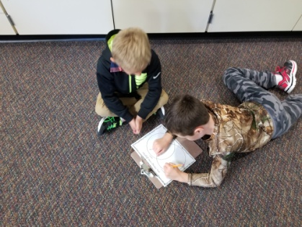
Halloween
We will be trick-or-treating at Pinecrest around 12:30. After trick-or-treating, we will head back to our classroom to have our Halloween snacks at 2/be ready for the parade at 2:45. After the parade, students will need to head back to the classroom to get backpacks, even if they are being picked up. If you are attending the parade and plan on picking up your child, I would appreciate if you could send in a note so I can be organized on who is going where! I have received a good amount of people volunteering to bring a snack on Halloween, so we should be all set!

