bdubord@ncajets.org http://bdubord.weebly.com
SECOND GRADE NEWS October 5, 2018

Upcoming Dates:
10/12- Early Dismissal @ 12:00- Teacher PD
10/16-Pizza Sale Pick-Up 2:30-4:30
Next Week’s Specials
Monday- Music
Tues- MOBY- Please have books returned by Monday
Thurs- Library
October 20- NCAP Fall Carnival

Weekly Notes:
~ Thanks to all who have been reading at home! Remember to fill out the Pizza Hut Book-it log for anytime your child is doing any reading.
~NCAP is hosting a Fall Carnival on October 20th from 11- 3 at the Community Club in Hermansville. Costumes are encouraged!

Reading: Next week we will be reading a folktale called The Strongest One. We will be discussing folktales and fables for the next two weeks. Fables and folktales are often a favorite to read. The Strongest One is written as a play, so we will read it multiple times next week focusing on fluency and using expression when reading.

Spelling: Homework next week will be 10 points from the Spelling Contract. Remember, all spelling words and spelling city links are posted on my website. If you do not have it saved, you can access my website by going to the North Central School webpage and finding my name. Next week’s words will be consonant digraphs. Words will be: bunch, that, wish, patch, when, what, math, them, shape, whale, itch, chase, whiskers, switch, shrimp

Math: We will finish Unit 2 next week. Unit 2 has consisted of a variety of different addition strategies, focusing on making 10s to have easier numbers to add. (ex: 10+5 is easier to add then 7+8, so we look for a group of 10.) Next week we will start subtraction strategies.

Language/Writing: This week, we worked on Fall Narratives. We are learning about the writing process, and students are doing a great job adding details. We also finished our sentence unit. Students had fun rearranging sentences. A tough thing with the skill of sentences is actually applying it. Students may know the rule, but remembering to capitalize/use punctuation, etc is often more difficult. We reinforce this skill ALL YEAR! We also practiced capitalizing product names, holidays, and geographic names. Students made capital letter collages, and practiced applying this concept in writing. This will continue next week.

Science/Social Studies: This week we discussed maps and directions. Next week we will be starting some of our Science standards on landforms and the work of water.

Name: ____________________________________

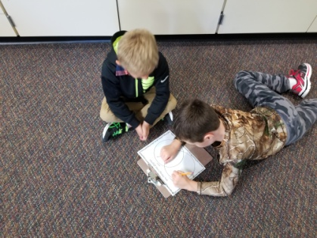
We will be holding a Foster Grandparent Fundraiser Next Week!
When: October 8th-12th
Each teacher will be given a bucket to put in their classrooms to keep during that week. Students can bring in any spare change or donations their family would like to make for the program. At the end of the week, the buckets will be collected.
The classroom that has won will receive an extra special recess courtesy of Mr. Adams!
We appreciate any support of this FANTASTIC program at our school!

Students work on
rearranging
Fall sentences.

