bdubord@ncajets.org http://bdubord.weebly.com
SECOND GRADE NEWS October 6, 2017

Upcoming Dates:
October 13- Early Dismissal @ 12:00- Teacher PD
October 17-Pizza Sale Pick-Up 2:30-4:30
October 20- Box Tops Due
Weekly Notes: This week we started our W.I.N groups and small groups. Students have been doing a great job adding this new routine in the schedule, and I find they look forward to the change of pace each day.
~ Thanks to all who have been reading or doing Xtra math at home! Remember to fill out the Pizza Hut Book-it log for anytime your child is doing any reading.
~NCAP is sending a T-shirt order form home today! Also, please return Residency form from last week if you haven’t already.

Reading: Next week we will be reading a folktale called The Strongest One. We will be discussing folktales and fables for the next two weeks. Fables and folktales are often a favorite to read. The Strongest One is written as a play, so we will read it multiple times next week focusing on fluency and using expression when reading.

Spelling: Homework next week will be 10 points from the Spelling Contract. Remember, all spelling words and spelling city links are posted on my website. If you do not have it saved, you can access my website by going to the North Central School webpage and finding my name. Next week’s words will be consonant digraphs. Words will be: bunch, that, wish, patch, when, what, math, them, shape, whale, itch, chase, whiskers, switch, shrimp

Math: We will finish Unit 2 next week. Unit 2 has consisted of a variety of different addition strategies, focusing on making 10s to have easier numbers to add. (ex: 10+5 is easier to add then 7+8, so we look for a group of 10.) Next week we will start subtraction strategies.

Language/Writing: This week, we worked on writing informational paragraphs using information learned about the desert. Students did a fantastic job! We also practiced capitalizing product names, holidays, and geographic names. Students made capital letter collages, and practiced applying this concept in writing.

Science/Social Studies: This week we went outside and created a map of our own community. Students included a map key, compass rose, and various buildings near our school. Next week, we will be working on landform projects. Students will be researching a landform to share with the class.

Name: ____________________________________

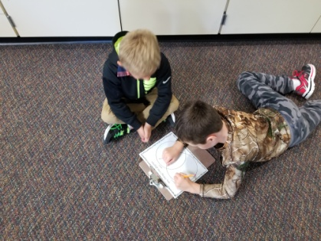
This week, we started Accelerated Reading. By 2nd Grade, AR is done pretty much independently. I try to encourage students to take at least one test a week. Students may use the iPads to take a test when they are ready. This week, all students were able to check out an AR book. This book can go home so students can practice. If your child would like to take it home, I have told them to put their book in their take home folder. (With the importance of reading at home, I strongly encourage students to bring their AR book home!) Please note: I do not count AR as a homework grade, etc. so it us up to your child (and you!) if the book goes home each week.

(At Left:
Students create a
map of our school
community. )

(Below: Students
create a Capital
Letter collage)
