bdubord@ncajets.org http://bdubord.weebly.com
SECOND GRADE NEWS September 13, 2019
Weekly Notes: This week we finished most of our beginning of the year testing. Beginning of the year baseline reading test reports went home today.
~Title One contracts went home today. Please sign and return. Our school is a schoolwide title school, so these go home to everyone!
~ This week, our class got the opportunity to check out library books from Moby. (Menominee County Library Bookmobile) Our regular school library day is Monday.
~Thanks for all who have brought snacks for our calendar!
~ FYI: I allow students to keep water bottles with water at their desk, so feel free to send. Please know that they will be responsible for making sure it gets home/washed as needed.

Reading: Next week we will and move into a non-fiction text on space. We will be discussing finding the main topic and details in a text. This can be a hard skill for students, so we will use a variety of different articles and activities to help us practice. This week we took our first reading test. Reading tests are each Thursday.

Spelling: Spelling lists will go home in folders on Monday. Spelling tests will be Friday. Although there is no required homework, students should be practicing their words at home. Next week’s words will be long vowel sounds. Words will be: tune, page, nose, space, size, fine, mice, late, cube, blaze, home, vote, erase, spice, confuse

Math: Next week we will be continuing with our Jump Math Unit 1. We will finish up even and odd numbers, and move into doubles plus 1 and 2. The goal is that students will eventually use these math strategies to solve mental math problems.

Language/Writing: For Language next week, we will continue working on creating complete sentences, but we will also work on expanding sentences using details. This will be a main focus in our writing next week as well.

Science/Social Studies: Tuesday our class will learn about our country’s constitution, as it is Constitution Day. The rest of the week we will be discussing rural and urban areas.

Name: ____________________________________

Upcoming Dates:
Elementary Pictures- September 23rd- Forms went home today

Pizza Fundraiser- Ends September 19th

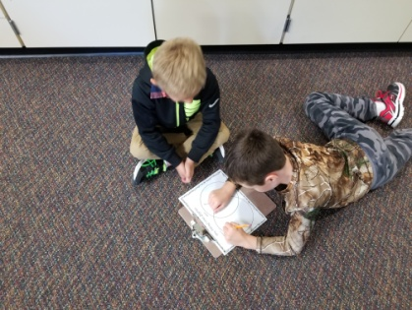
This year, our ISD is making a push for Social Emotional Learning. Teachers will teach and discuss these concepts with students in order to help build a positive learning community where students respect others and can handle emotions appropriately. The ISD has provided grade appropriate weekly Michigan Virtual lessons for the teacher to guide the class through. We will use the weekly lesson to fit our SEL Skill of the Week. This week our theme was why rules are important, and next week our skill will be showing respect at school.

Please remember the pizza fundraiser packets that went home last week. Any student that sells 1 item gets to attend the pizza party.
