bdubord@ncajets.org http://bdubord.weebly.com
SECOND GRADE NEWS September 15, 2017
Weekly Notes: This week we finished most of our beginning of the year testing. We will use this information to help us form groups so your child gets what they need to help them succeed. I am hoping to send home our class schedules next week.
~ This week, our class got the opportunity to check out library books from Moby. (the Bookmobile) A card is coming home today for you to sign to allow them to continue to check out books when Moby comes each month.
~If you have not brought in a snack yet, we would appreciate a snack to put in our snack cupboard! It can be very simple: A bag of pretzels, animal crackers, etc. work out great, and usually are less expensive than individually wrapped snacks.
~ Book Orders go home today!

Reading: Next week we will switch from characters and setting and move into a non-fiction text on space. We will be discussing finding the main topic and details in a text. This can be a hard skill for students, so we will use a variety of different articles and activities to help us practice. This week we took our first reading test. Reading tests are each Thursday, and we take Spelling tests on Friday.

Spelling: Homework next week will be 10 points from the Spelling Contract. Please email me or contact me on Remind 101 if you have any questions regarding this. Thank you to all who helped with the contract at home this week. We have been practicing different activities all week. Reminder: I have the class take home the Take Home folders each day, (except Friday) so then they always have access to the Spelling Words and contract. Next week’s words will be long vowel sounds. Words will be: tune, page, nose, space, size, fine, mice, late, cube, blaze, home, vote, erase, spice, confuse

Math: Next week we will be continuing with our Jump Math unit 1. We will finish up even and odd numbers, and move into doubles plus 1 and 2. We will use manipulatives and hands-on activities to help us understand this concept.

Language/Writing: For Language next week, we will continue working on creating complete sentences, but we will also work on expanding sentences using details. This will be a main focus in our writing next week as well. This week, we have been writing about friends and what makes them so special.

Science/Social Studies: Monday our class will work with Mrs. Veeser’s class to complete some activities to celebrate Constitution Day. The rest of the week, we will continue to discuss types of communities.

Name: ____________________________________

Upcoming Dates:
September:
21st- Book Orders DUE
27th- Pizza Sale ENDS
25th- Elementary Pictures- Forms went home last week!

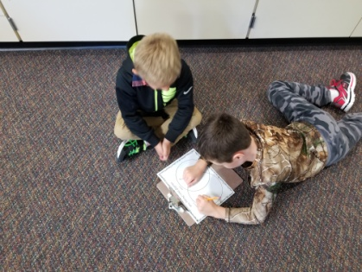
Today, packets are going home for the Pizza sale. The pizza sale is our school’s main fundraiser, and this is how we have been able to purchase items such as our interactive projector. Any amount of participation helps! If your child participates, even by selling one item, they will qualify for a pizza party. The student who sells the highest dollar amount school wide will win $100 cash!

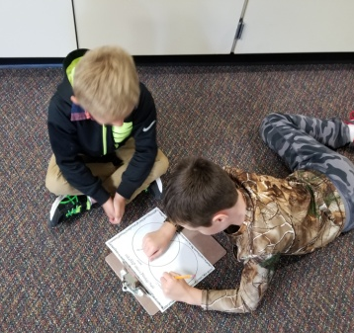

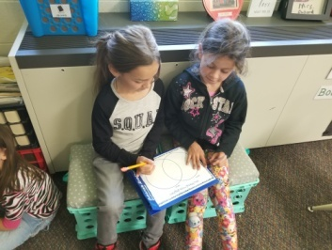
Students work together to create “new friend” Venn Diagrams.

