[bdubord@ncajets.org](mailto:bdubord@ncajets.org) <http://bdubord.weebly.com>

SECOND GRADE NEWS September 20, 2019

**Weekly Notes:**

**~Thanks to all who participated in our fundraiser! WE appreciate the support for our school!**

~ Thanks to all who have signed up for the Remind app. Please let me know if you need me to resend info so you can join.

**Reading:** Next week we will be reading Henry and Mudge and the Starry Night. We will be practicing describing the characters and setting based on the story and pictures. This week, we worked on Main Idea. Students worked with a group to determine the main idea of a paragraph. They created a poster and presented their poster to the class. Students did a great job working together in groups. See pictures below.

**Spelling:** Next week’s words will be consonant blends. Words will be: stop, clip, strap, stream, nest, hand, mask, twin, brave, breeze, ask, state,

**Math:** This week we finished Unit 1 of Jump Math. Students learn a variety of strategies, many with the goal of mental math, and I remind them what works best for one student may not be the best strategy for another. Next week we will continue Unit 2, which starts as a review of using number lines and correctly spelling number words.

**Language/Writing:** For Writing next week we will continue learning about narratives. It has been fun to see what great details students are already using in writing.

**Science/Social Studies:** Next week we will be

learning about maps and how to read them. We

will also do a team building activity in Science.

Name: ____________________________________

**Upcoming Dates:**

**Elementary Pictures are September 23rd!**

**October 11- Noon Dismissal**

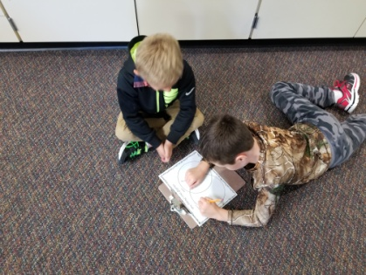

**SEL Skill of Week**

This week we worked on showing respect at school. We discussed not only being respectful in words and actions, but our tone of voice as well. Next week we will be learning about the Golden Rule and how we should treat others.

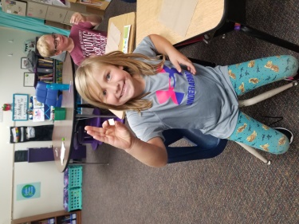

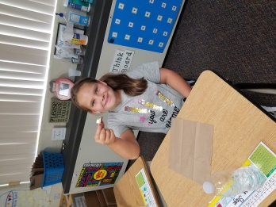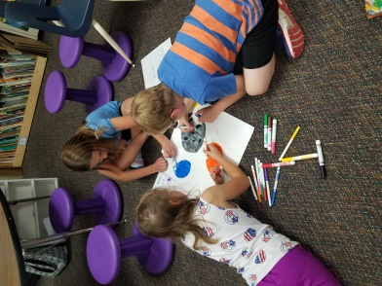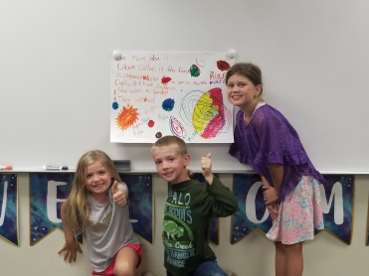

This week we learned about how astronauts need to eat food that has been dehydrated, etc. We sampled freeze dried ice cream!