[bdubord@ncajets.org](mailto:bdubord@ncajets.org) <http://bdubord.weebly.com>

SECOND GRADE NEWS September 21, 2018

**Weekly Notes:**

**~Thanks to all who participated in our fundraiser! Monday will be the final date to accept orders.**

~Thank you for all the delicious snacks this month! We appreciate it.

~ Thanks to all who have signed up for Remind 101. Please let me know if you need me to resend info.

**Reading:** Next week we will be reading Henry and Mudge and the Starry Night. We will be practicing describing the characters and setting based on the story and pictures. This week, we worked on Main Idea. Students worked with a group to determine the main idea of a paragraph. They created a poster and presented their poster to the class. Students did a great job working together in groups. See pictures below.

**Spelling:** Homework next week will be 10 points from the Spelling Contract. Thanks to ALL who helped at home this week! Next week’s words will be consonant blends. Words will be: stop, clip, strap, stream, nest, hand, mask, twin, brave, breeze, ask, state,

**Math:** This week we finished Unit 1 of Jump Math. Please note that we have been learning different strategies for solving problems. If a certain one does not make sense, do not panic. Students learn a variety of strategies, and I remind them what works best for one student may not be the best strategy for another. Next week starts Unit 2, which starts as a review of using number lines and correctly spelling number words. We will also be forming review groups based on Unit 1 tests.

**Language/Writing:** Next week we will be starting our Writer’s Workshop. Students will be encouraged throughout the year to write with creativity about things that interest them.

**Science/Social Studies:** Next week, we will finish our unit on rural, suburban, and urban communities. We are also planning on doing a team building challenge to help

prepare us for working

in teams during Science.

Name: ____________________________________

**Upcoming Dates:**

**9/24- Elementary Pictures**

**9/26- Title 1 Night- I hope to see you there!**

**10/12- 12:00 Dismissal**

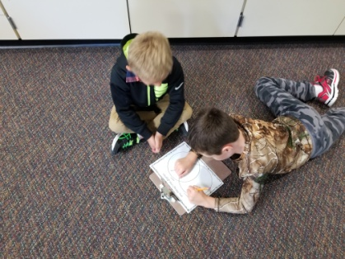

**September 26th will be our Title One Night from 5-7 pm. I strongly encourage ALL to attend! There will be information regarding Title Services, IRIPs, etc. A children’s performer, Tom Pease, will also be there, and refreshments will be served. It should be a fun night!**

**Next Week’s Specials:**

Monday- Music @3:05

Tuesday- Computer @8:05

Wednesday- Art @8:05

Thursday: Library

*(Below) We read about astronauts needing to eat dehydrated food in space. Students got to try an “astronaut treat”- freeze dried ice cream sandwich. We decided that ice cream in any form is pretty delicious! ☺*

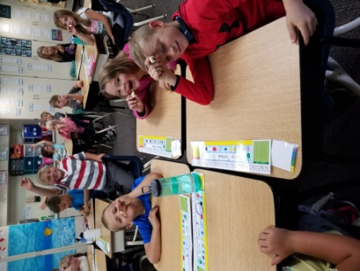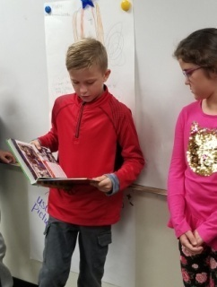

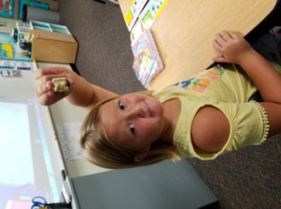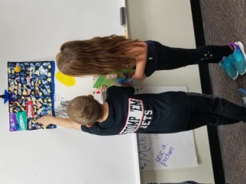

**No Report- Sub**

**Mrs. Dubord at Data Day**