[bdubord@ncajets.org](mailto:bdubord@ncajets.org) <http://bdubord.weebly.com>

SECOND GRADE NEWS September 28, 2017

**Upcoming Dates:**

10/12- 12:00 Dismissal

Next Week’s Specials-

Mon-P.E.

Thurs-Computer

Fri- Art

**Library will be either Tues or Thurs

**Weekly Notes:**

Today, a Book It Reading Log is going home. Anytime a student reads at home, they can record it on the log either by writing the minutes or Book Title. I wrote 200 minutes as a goal, but please know that this is just a goal- I am happy for any reading done at home! ☺ At the end of the month (or once goal is met), they can return the chart to me for a free personal pizza from Pizza Hut. Remember: Reading can come in many forms- reading aloud, silent reading, listening to a story, etc. Let me know if you need any resources (there are some great online sites with book read alouds I will gladly share!)

**Reading:** Next week we will be reading a nonfiction text: *A Walk in the Desert.* We will be discussing main topic, idea, and details. We will also be looking at how the images help us to understand the text.

**Spelling:** Homework next week will be 10 points from the Spelling Contract. Next week’s words will be endings –ing and –ed. We spend the week reviewing when you double consonants or drop an e. Words will be: dropped, dropping, excited, exciting, lifted, lifting, hugged, hugging, smiling, smiled, talked, talking

**Math:** Unit 1 tests will be going home today. We will continue with addition strategies next week. We will be discussing the strategy of making a ten to help us add. We have been practicing what numbers make 10 using different math practice games. Remember, the more students practice their facts, the easier a lot of these skills will be!

**Language/Writing:** This week, we started our Writer’s Workshop where we get in a writing routine with a mini lesson, writing time, and share time. Next week we will start Fall narratives. In Language, we will be focusing on capitalizing holidays, product names, and geographic names.

**Science/Social Studies:** This week finished our rural/urban unit. We also learned about Johnny Appleseed by creating a map and tasting different apples. Next week, we will continue with our map unit.

(At right- Students work together to rearrange

sentences using index cards.

Name: ____________________________________

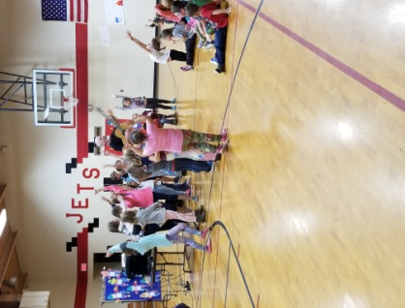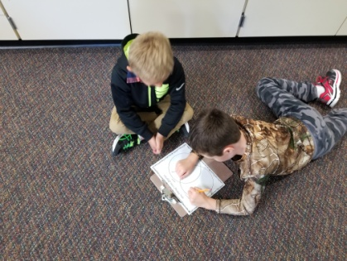

Title Night

Thanks to all who

attended our Title

Night on Wed! It

was a great night

for all, and I had so

much fun watching

the kids singing

excitedly about

reading.

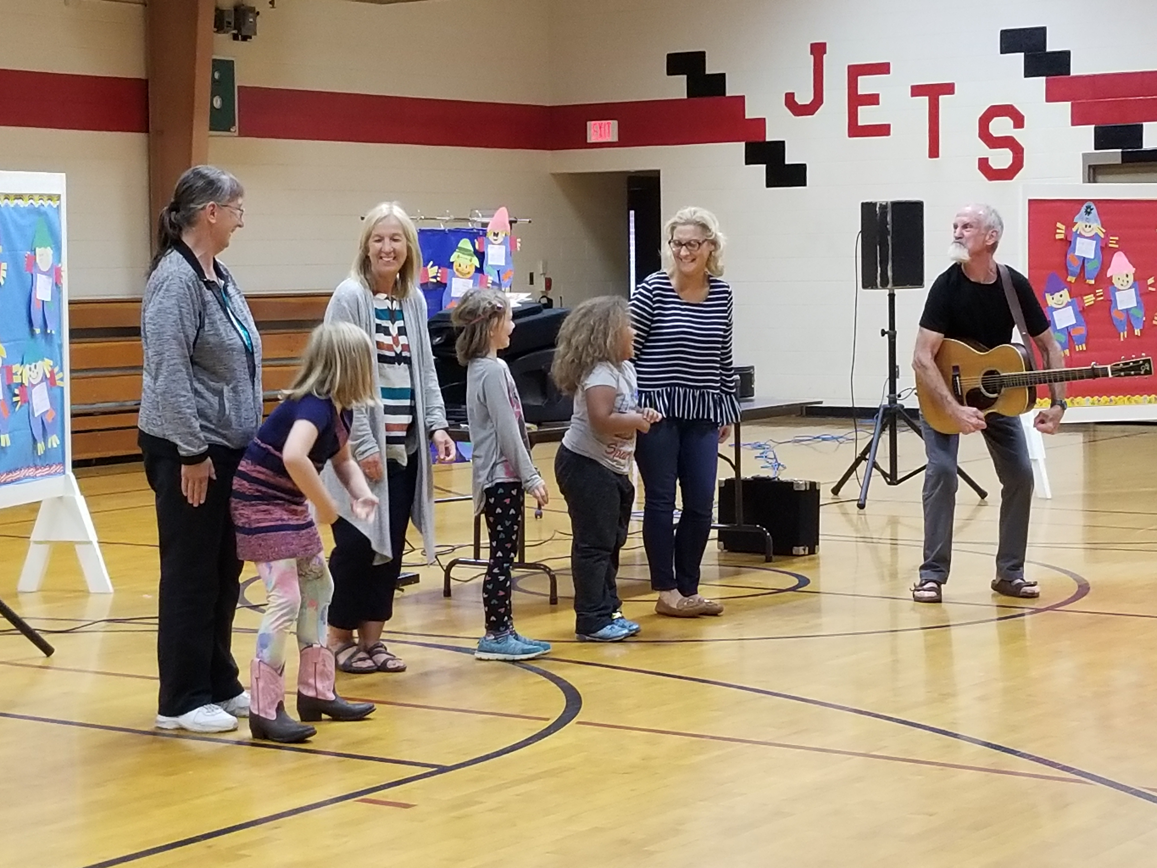

**September Book Order**

Today your child will be receiving a free book from the September Book Order thanks to generous donors supporting our class! Each child will receive a free book each month. They had the option to select from multiple books, and the orders came in this week. **We are excited about our first book order!**

