SECOND GRADE NEWS

[bdubord@ncajets.org](mailto:bdubord@ncajets.org) September 8, 2017

*Students practice a math game.*

**Important Notes:**

* All parents are receiving a Title One contract to sign. Our school is a full title school, and we have Title Aides in our classroom working with ALL students.

*Headphones- We use computers often in class, and we encourage students to bring in their own set of headphones or earbuds. They will be stored in a bag in their extra supply drawer for their use only!

*This year I am starting a website: <http://bdubord.weebly.com/> It is still very basic, but I do have Spelling words uploaded under the Spelling Tab, as well as a link to a website, Spelling City. This website allows students to play games to practice words, and the links on my website direct you right to each week’s list. The games work on a cell phone as well. (This site counts toward Spelling Contract too!) Newsletters can also be found on the website.

**Reading:** Next week we will be reading our first story from our reading series: *Iris and Walter.* It is a fiction story, and we will be focusing on the standards of character and setting. Small groups (based on your child’s needs) will not start next week as we get into our routines and finish beginning of year testing.

**Spelling:** Our first week’s words will be short vowels. For homework, I send home a spelling contract with choices for students to use to practice their words. We did not go over this in class yet, so there will be NO HOMEWORK next week as we get familiar with the contract. You will notice the list and contract going home in the take home folder. Students may practice their words using the contract at home, but are not required to do so. Please keep the contract and words in the take home folder, so your child has it each week. **Next week’s Words: *drum, rock, chop, list, sack, tag, desk, rib, job, mess, sad, dust, pocket, lettuce, engine***

**Language/Writing:** We are reviewing what makes a complete sentence and practicing this skill. We have been discussing writing narrative stories.

**Math:** We started our first Jump Math Unit. The year starts with a basic number sense review, and we will move into even and odd numbers next week.

**Science/Social Studies:** Throughout the year, we rotate between Science and Social Studies. Next week, we will be learning about rural and urban communities. This matches our reading story. I try to make Science hands-on and exciting. I am planning to do an introductory team building challenge next week to help prepare us for the group work we do in Science throughout the year.

**THANK YOU to all who have connected using Remind 101. I am finding it a great way to communicate, and it will help when reminding you of events. Please consider signing up if you have not. I am resending directions home today.**

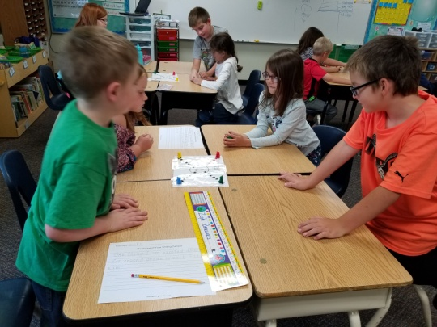

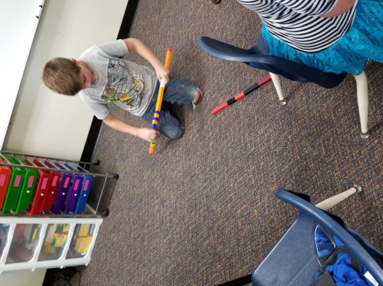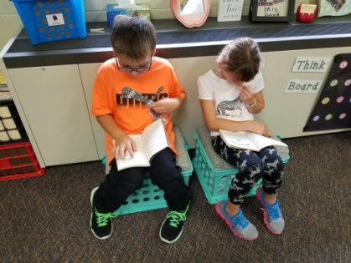

*(Above) We discussed ways to use manipulatives as tools. (Below) Students enjoy “Bookworms” (Gummy worms) while we set procedures for the class library and silent reading.*

**Upcoming Dates:**

**September:**

**11th- NCAP meeting @ 6:00- Please consider joining our parent group if you have not yet!**

**15th- Pizza Sale STARTS**

**25th- Elementary Pictures**