bdubord@ncajets.org bdubord.weebly.com
SECOND GRADE NEWS April 12, 2019
Upcoming Dates:

April 17th- Book Orders Due/ ~Return final Take the Challenge slip
~Easter Egg Hunt at Pinecrest
April 18th- 11:50 Dismissal- Teacher PD
April 19th- No school

On April 17th, Pinecrest has invited K-2 students for an Easter Egg Hunt. This will be our first year doing this, so we are excited!

Notes: NO Newsletter will be going home on April 18th. We will have a very busy week, so clips will not move as much, and there will not be many updates. I will include words for April 22-26 this week.
Book Orders are going home today. They will be due on April 17th. Yearbook order forms are also going home today too.

Reading: Next week we will be reading a story called Horace and Morris, a story about friendship. We will be discussing character traits, but also bringing up the important discussion of being kind to one another. We will discuss ways we can be friends to all and how important it is to be kind to everyone. The week after we will continue on story structure and read the story The Signmaker’s Assistant.

Spelling: There will be 10 points from the Contract due by April 18th. There will be NO advanced for the next week, as it is a 4 day week. Words next week will be silent consonants: cliff, cough, enough, giraffe, graph, laugh, phone, puff, photo, rough, stuff, tough
Words for the week after will be: August, auto, because, caught, chalk, draw, fault, launch, talk, taught, thaw, walk

Math: This week we finished our 3 digit addition and subtraction unit. We are still reviewing skills in math groups, and we will take our test soon. Next week we will move into measurement in inches, while continuing to gain confidence in our addition and subtraction.

Language/Writing: This week we finished our unit on reflexive pronouns. Next week we will be discussing informal and formal language, and when to use each. For example, you talk differently to the principal than a friend on the playground. For writing, we will work on finishing our group research projects on recycling. (See pictures of us researching at right)

Social Studies/Science: Next week we will look into
code.org again and continue with building problem
solving skills.

Name: ____________________________________

Our walking club kicked off this week! We have had a great group participate, and I have enjoyed getting to visit with the students as we walk through the halls getting in our laps!
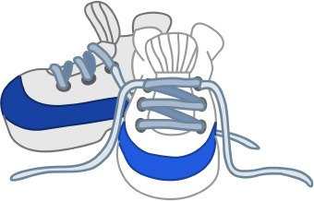
Take the Challenge continues over next week. Thanks to all who returned their slips. By participating in teaching the Take the Challenge curriculum, our school was able to receive grant money to be used toward bettering the health of students at our school.

Our Haiku Poetry

