[bdubord@ncajets.org](mailto:bdubord@ncajets.org) bdubord.weebly.com

SECOND GRADE NEWS December 6, 2017

**Upcoming Dates:**

**December:**

12th- Bookmobile- Have books in by Monday

12th- Santa’s Secret Shop Shopping Day

14th- JETS Day: Wear NCA colors

20th- Christmas Program 1:00/6:00

21st- Christmas Party@ 2:00

**Christmas Break: Dec 25-Jan 1**

**This week, there will be no behavior reports going home for Thurs/Fri, as I was out Thurs/Fri for a funeral. I apologize if very little work is sent home in folders. Grades will be updated after the weekend, and Unit 2 test sheets will be sent home next week.**

**Our Santa’s Secret Shop Day is December 12th. Please refer to NCAP note that went home, or contact me with questions.**

**Reading:** Next week we will be reading a fiction story called Dear Juno. We will be focusing on drawing conclusions while reading and finding evidence in the text.

**Spelling::** There will be 10 points from contract due on Friday. We will be doing long o words next week. The words and spelling city links are posted on my website. On Monday, we will be taking a pretest again to determine who will be getting the advanced list. Regular words are: goat, hold, show, most, bowl, float, toast, ago, open, told, toad, slow, almost, throat, and hollow

**Math:** This week we worked on addition with regrouping. We will continue to practice this skill next week too. We will also be working on subtraction skills next week.

**Language/Writing:** We worked on winter writing this week. For Language, students continued working on identifying possessive nouns and when to use an apostrophe.

**Science:** This week, we completed our Three Little Pigs Challenge. Students were given different materials and had to choose one, along with a fastening supply, to plan and then create a house for “the 4th Little Pig.” We then tested our designs to see who could outlast the “Big Bad Wolf.” Students used great problem solving/teamwork and had fun! See pictures below.

Name: ____________________________________

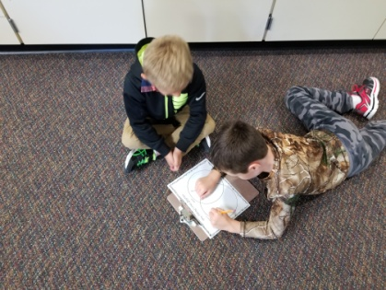

**December 20th- Christmas Program 1:00 & 6:00- If your child will be picked up after the 1:00 performance instead of returning to school, please send a note with them to school that morning, or contact me via email or Remind. After the program can be very chaotic, and this helps me to plan!**

**Christmas Party**

**The lower elementary Christmas parties will be held on Thursday, December 21st. Our party will start after recess, around 2:00. We will be having treats, and we will also have a gift exchange. For the gift exchange, girls can bring in a wrapped gift labeled “To Girl”, and boys can bring in a wrapped gift labeled “To Boy”. Students will then randomly choose a gift to open, so every student in the class will go home with a surprise gift. The suggested amount to spend is $5.00. Please let me know if you do not want your child to participate in the gift exchange. If you would like to bring in a treat for the party, feel free to let me know what you will be bringing to ensure we have enough variety. Let me know if you have any questions!**

Our Haiku Poetry

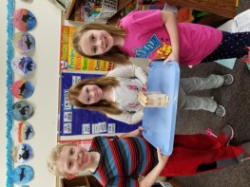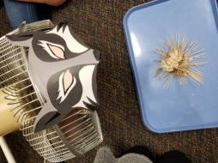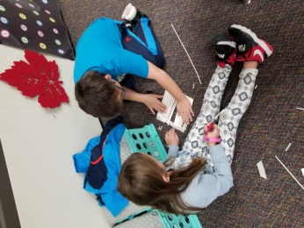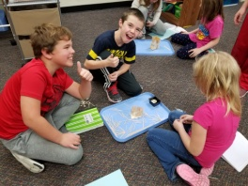

**No behavior report- Substitute Teacher**