bdubord@ncajets.org bdubord.weebly.com
SECOND GRADE NEWS February 15, 2019
Upcoming Dates:
Feb 18-20- Book Fair
Feb 19th- Class Book Fair Day
Feb 19th- Book Fair Family Night 3:00-6:00
Feb 21st- 100th Day- Feel free to have your child decorate a t-shirt to celebrate!
Feb 21st- Early Dismissal@ 11:50- Teacher PD
Feb. 22nd- No school- Teacher PD
Feb 25th- End of Pizza Sale
March 5th- Pizza Sale Pick Up

Below: Students practiced measuring items this week.
Students played a 100s chart Battleship game for Valentine’s Day.
~Monday we celebrated meeting our class compliment board (when someone compliments us for our choices, we get a star!) We had an ice cream sundae party.
~Thanks to all who helped make our Valentine’s Day a success! We had a great day as a class.
~The pizza fundraiser has been extended to Monday, Feb 25th. Orders can be picked up from 2:30-4:30 on March 5th.
~There will be a Book Fair in the library next week from Feb 18-20th. There is a Family Shopping Night on Tuesday. Our class will also go on Tuesday.

Reading: Next week we will be continuing with text features, including comparing and contrasting information we can find from them. Informational text can be more difficult for students to remember, so we have been really working on looking at diagrams, etc to see what we can learn from them.

Spelling: There will be 10 points from the Contract due by Thursday, Feb 21st. There will be no advanced list next week due to the short week. List words will be: about, around, crown, downtown, flower, gown, ground, howl, mouse, pound, sound, south

Math: This week we worked on measurement, including adding measurements together. Next week we will finish measurement, and move into Part 2 of our math series, starting with number sense concepts. Congratulations Presley for finishing Subtraction Facts in Xtra Math! If you would like info on how to access at home, let me know!

Language/Writing: Next week we will be working on irregular verbs that do not follow the rules. Ex: keep-kept For writing, we will be working on getting organized with our informational animal books. We will be discussing adding things like diagrams to our own writing.

Social Studies/Science: Next week we will be likely finishing our Unit on Matter. We have a fun Mystery Science activity we will be doing.

Name: ________________________________________

Name: ____________________________________

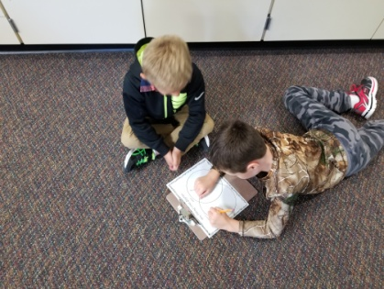

Our Haiku Poetry

