bdubord@ncajets.org bdubord.weebly.com
SECOND GRADE NEWS March 8, 2019
Upcoming Dates:
Monday, 3/11- 11:50 Dismissal- Teacher PD

3/25-3/31- Spring Break
March: Reading Month Activities- Refer to calendar
3/13- Read a book to a Family Member
3/15- Camp Out with a good book- Bring a Flashlight

(Below) Students share a favorite book together.

Don’t forget to change your clocks this weekend! Daylight Savings time begins. This week Steph Meck from MSU Extension came in to discuss nutrition. We learned about proteins and tasted hummus. I was impressed with how many tried something new! The last few weeks we have started the introduction to cursive writing. In 2nd grade, I just introduce each lowercase and uppercase letter. Students are not required to write in cursive, but I encourage them to learn and practice each letter. (Generally, students are very excited to learn this new skill!)

Reading: Next week we will have a Unit 4 Review Week. We will be reviewing how to compare and contrast two different articles, and then write about them. This will help prepare them for the Unit Test Writing Prompt which is often a struggle to include enough details.

Spelling: There will be 10 points from the Contract due by Friday, March 15th. There will be NO advanced for this week due to unit test. Words will be: ankle, title, apple, cable, purple, able, bugle, bundle, bubble, giggle, sparkle, and tickle. The Spelling City link is on my weebly.

Math: This week we started with 3-digit place value. Students are doing very well. We will continue with this skill next week, starting with writing number words. We have been reviewing the skills of two digit addition and subtraction with regrouping. Students often combine the two different strategies after learning both.

Language/Writing: This week we have pretty much finished our informative animal books. Students are so proud of their work. Throughout this unit, they have completed all their own research for facts, divided their facts into different headings, included a table of contents and diagram, and some have even been drawing maps! It has been fun to see their excitement over having something they created from start to finish.

Social Studies: We will continue learning about our communities and where we live- going into our state, country, and continent.

Name: _______________________________________

Name: ____________________________________

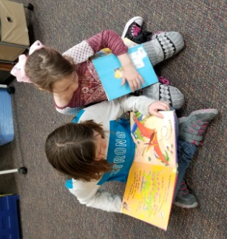
Our Haiku Poetry

Celebrations
This week our class voted Alyrae as Citizen of the Week. Students said that Alyrae was “a good helper and friend”. Keep up the good work!

