bdubord@ncajets.org bdubord.weebly.com
SECOND GRADE NEWS May 17, 2019
Notes: If you have not brought a snack in a while, we are out of snacks in the classroom! Thanks to those who have kept us so well stocked this school year.
This week Steph Bruno visited our class to talk about nutrition. She focused on fruits. A newsletter is going home from her. We also took some of our end of the year testing this week, and will finish up next week.

Reading: Next week we will be reading a story called A Birthday Basket for Tia and drawing conclusions as we read.

Spelling: For the rest of Unit 6 words we focus on the word meanings, as they involve endings or suffixes. (One of our Language standards too!) So, there will be no advanced list for the rest of the year. I know it is a busy time of year, so students have the opportunity to complete contract at school (if they take the initiative). Words for next week will be: action, caution, feature, fixture, future, mixture, motion, nation, nature, picture, section, station

Math: Next week we will be finishing up counting coins and money. We will then move into geometry standards and shapes.

Language/Writing: We will continue writing realistic fiction narratives. For Language we will talk about words with multiple meanings.

Social Studies/Science: This week we learned about classifying animals and the way scientists study their characteristics. (see pictures below!) We will continue with plants next week.

Name:

Name: ____________________________________

Upcoming Dates:
May 20&21- Mrs. Dubord at ISD
May 23rd- Last book order due!
May 27th- No School- Memorial Day
June 10th- Field Trip to Rec Lanes/Strawberry Lake- See additional details
June 12th- Early Dismissal/Last day of school

SUMMER Opportunities
Summer Reading Program
Every Monday--June 24th -July 29th
10:30 a.m. Hermansville Ball Diamond Pavilion
No registration required...questions call Hermansville Library Branch 906-498-2253

Instructional Swimming and Gym
Y.M.C.A. Escanaba
June 24-27th
2nd - 4th grade students (current year)
Register online by June 1st
www.nmcschools.org
See blue note in your child’s folder for additional information.

Our Haiku Poetry

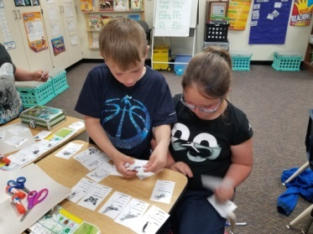
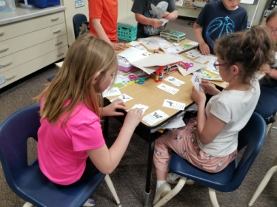
No Reports- Sub teacher

