bdubord@ncajets.org bdubord.weebly.com
SECOND GRADE NEWS May 4, 2018
Notes: This week Steph Bruno visited our class to talk about nutrition. She focused on grains. A newsletter is going home from her.

Reading: Next week we will be reading a story called A Birthday Basket for Tia and drawing conclusions as we read.

Spelling: For the rest of Unit 6 words we focus on the word meanings, as they involve endings or suffixes. (One of our Language standards too!) So, there will be no advanced list for the rest of the year. We will still take a pre-test each Monday, and students who score a 100% will be exempt from completing their contract that week. Words for next week will be: action, caution, feature, fixture, future, mixture, motion, nation, nature, picture, section, station

Math: This week we took our test on telling time. We did very well as a class, and it is fun to hear students reading the clock throughout the day! We will continue to review this skill for those struggling to catch on, as it can be difficult to apply/remember. Next week we will move into counting coins and money.

Language/Writing: This week we worked on editing and typing our favorite season writing. I am so impressed with the progress I have seen in the quality of writing over the year. Next week for language we will be reviewing words with multiple meanings. (Ex: bat, can)

Social Studies/Science: This week we finished our matter unit by making Oobleck. (2 Cups cornstarch, 1 cup water) Students were amazed to see that something had the properties of both a liquid and a solid. See a picture of us learning together below.
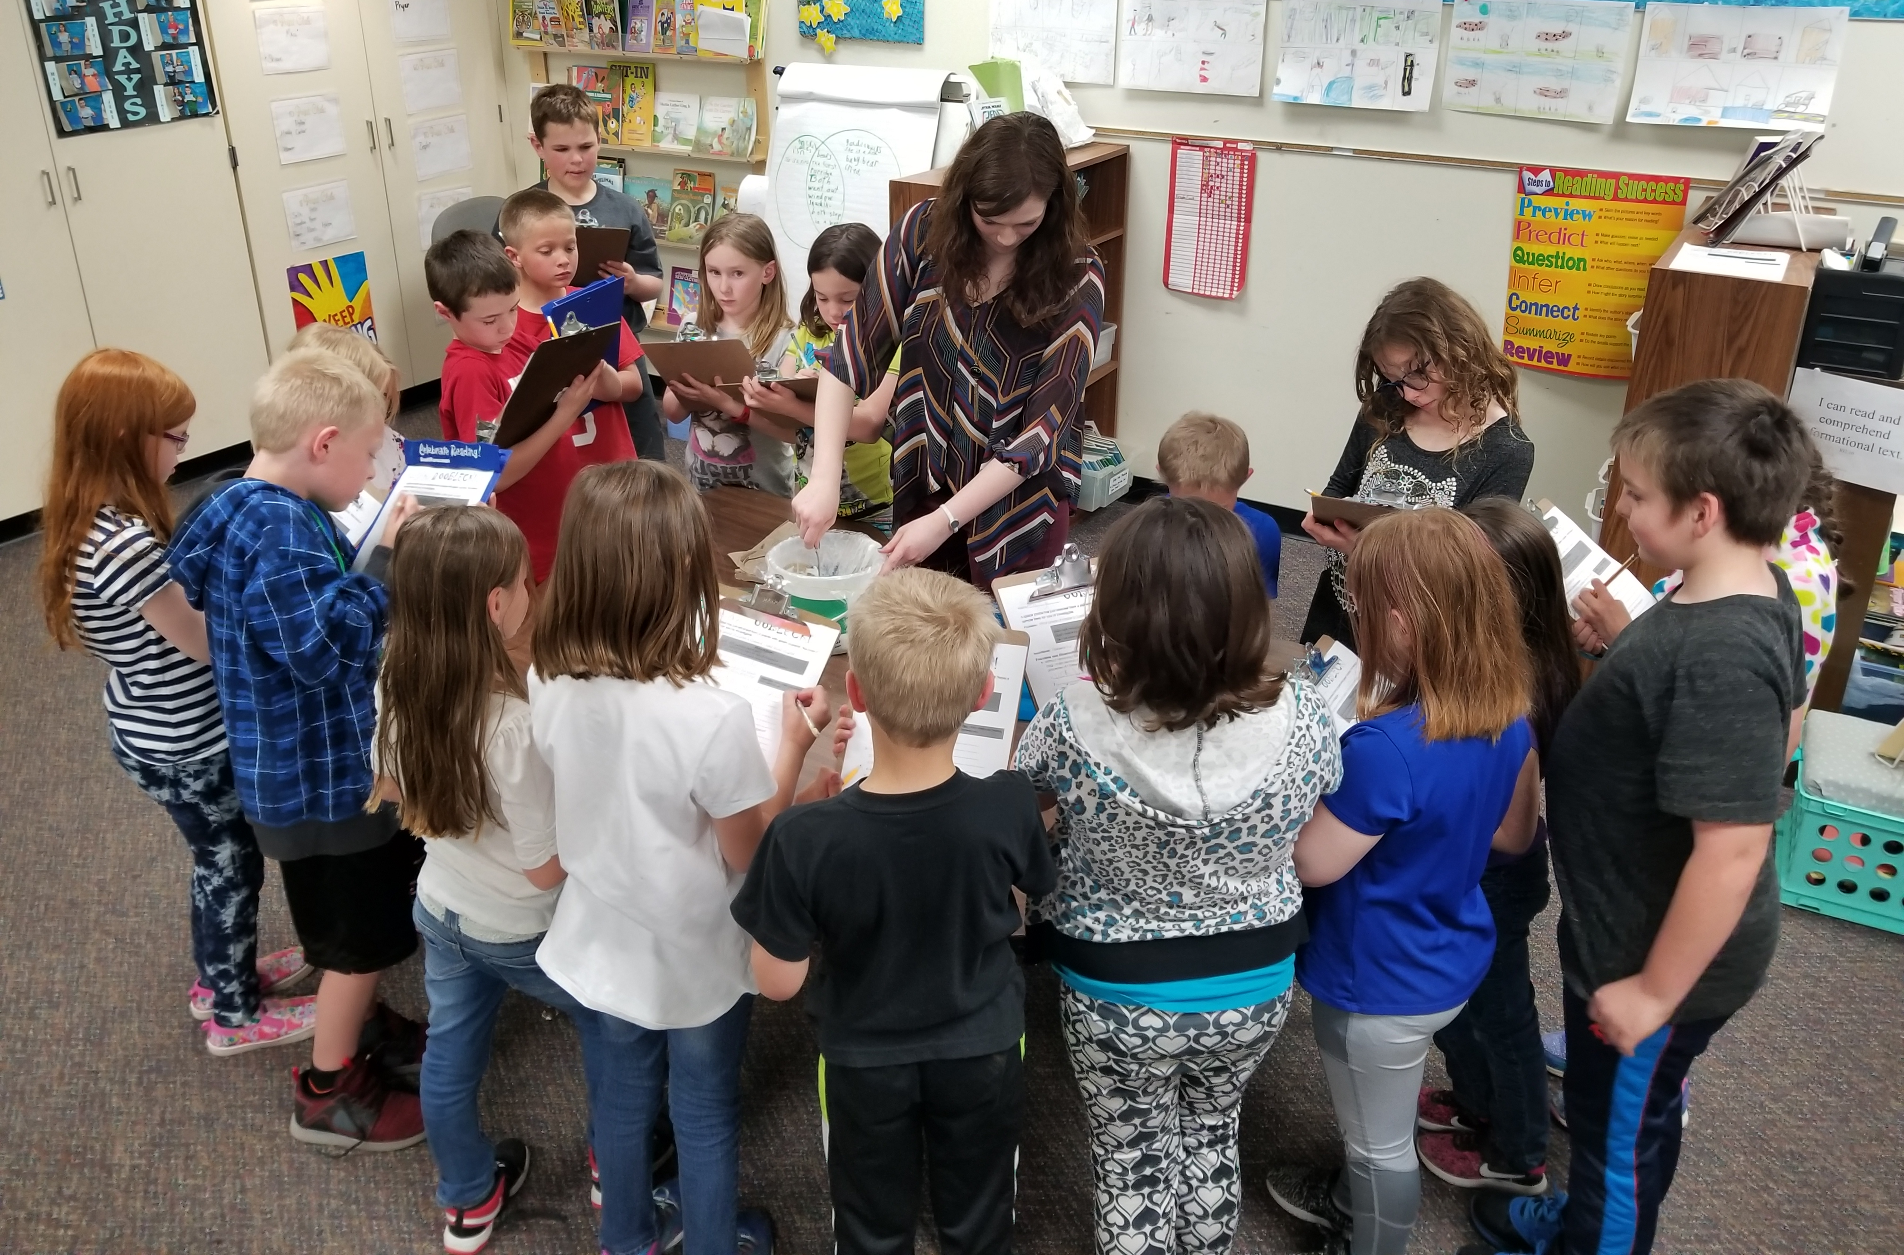

Name:

Name: ____________________________________

Upcoming Dates:

May 22nd: Kids Read Now Family Reading Night 4pm-5pm at the Elementary School

May 28th- No School- Memorial Day

June 4th- Field Trip

June 5th- Early Dismissal

June 6th- Early Dismissal/Last day of school

Our Haiku Poetry

Our 2nd Grade end of the year field trip to go bowling is currently planned for June 4th. The cost will be $5 per student. After bowling, we will have a picnic lunch at Strawberry Lake where we will spend our afternoon. More details will follow!

