SECOND GRADE NEWS

[bdubord@ncajets.org](mailto:bdubord@ncajets.org) bdubord.weebly.com October 25, 2019

**Important Notes: A November Snack Calendar went home today, as well as a Conference Sign Up Sheet. Unit 1 Reading test score sheets went home. We will be doing review groups during group time to go over missed questions. I noticed a lot of errors due to lack of taking time to read question carefully. For example, many selected sentences with no periods or capitals as correct in the grammar section, or chose words with the same beginning letter as rhyming words. Students tend to gain test taking strategies throughout the year, so we will see improvement!**

**Reading:** Next week, we will be reading a fiction story called *Ronald Morgan Goes to Bat.* We will be practicing the skills we worked on this week about characters responding to a challenge.

**Spelling**: Next week’s words will be contractions. We focus on the meaning of the words, as well as the spelling. To be correct, students must capitalize the "I" in I'll and I'm. Words are: I’ll, wasn’t, it’s, he’s, I’m, didn’t, who’s, she’s, we’ll, isn’t, hasn’t, hadn’t

**Math:** Unit 3 Tests went home today. Students did great! We will continue working on addition and subtraction strategies, learning vocab and understanding problems. Ex: ____ is ___ more than ____.

**Language/Writing (and Science!):** This week we worked on singular and plural nouns and will continue this next week. For writing, we have done a partner research project fitting with our science standard of landforms. Students will finish researching and typing next week, as well as making a model.

**Upcoming Dates:**

**Oct 28- Title 1 Night**

**Oct 31- Halloween Events: Parade- 2:30**

**Nov 1- End of 1st Quarter**

**Nov 6- Parent Teacher Conferences-Noon Dismissal**

**Nov 15- No School- Deer Day**

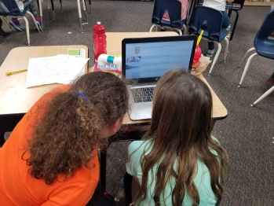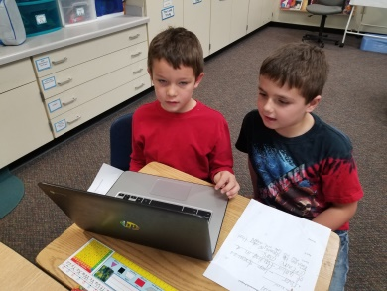

**Halloween**

In the afternoon, we get the opportunity to go trick-or-treating at Pinecrest with the 3rd Grade class. The bus will leave around 12:15, so students will be getting dressed in their costumes after lunch. Please send your child’s costume to school with them- they do not need to wear in morning. The school parade will follow in gym at 2:30**.** If you plan on going to Pinecrest with us, please meet us there. We will be there around 12:30.