SECOND GRADE NEWS

[bdubord@ncajets.org](mailto:bdubord@ncajets.org) bdubord.weebly.com October 4, 2019

**Upcoming Dates:**

**Library is Monday- Please return books**

**October 11th- Noon Dismissal**

**November 6th- Parent Teacher Conferences 1-6**

**Important Notes:**

~ Thanks to all who have been reading at home! Remember to fill out the Pizza Hut Book-it log if your child is doing any reading.

This week we started our reading and math groups. We also worked on logging onto student accounts for the first time on the Chromebooks. Students were excited to explore google docs, etc. (See Pictures!)

**Reading:** Next week we will be reading a folktale called *The Strongest One.*  We will be discussing folktales and fables for the next two weeks. Fables and folktales are often a favorite to read. *The Strongest One* is written as a play, so we will read it multiple times next week focusing on fluency and using expression when reading.

**Spelling:** Remember, all spelling words and spelling city links are posted on my website. If you do not have it saved, you can access my website by going to the North Central School webpage and finding my name. Next week’s words will be consonant digraphs. Words will be: bunch, that, wish, patch, when, what, math, them, shape, whale, itch, chase, whiskers, switch, shrimp

**Math:** We will finish Unit 2 next week. Unit 2 has consisted of a variety of different addition strategies, focusing on making 10s to have easier numbers to add. (ex: 10+5 is easier to add then 7+8, so we look for a group of 10.) Next week we will start subtraction strategies.

**Language/Writing:** This week, we worked on Fall Narratives. We are learning about the writing process, and students are doing a great job adding details! We also practiced capitalizing product names, holidays, and geographic names. This will continue next week.

**Science/Social Studies:** This week we started learning

about landforms and the work of water. We looked at

different landforms from around the world and modeled

some with clay. (See picture!)

Name: _________________________

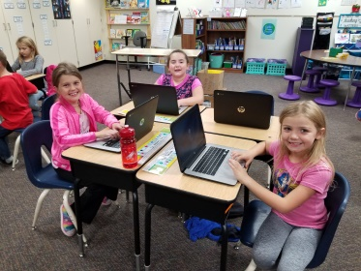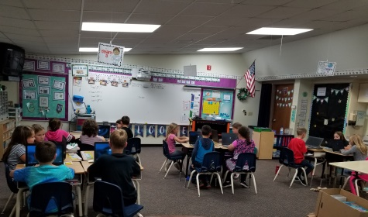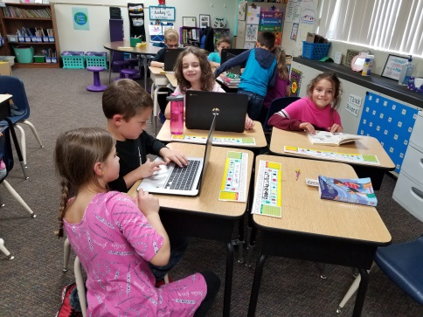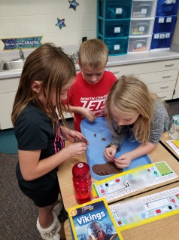

**No Report- Substitute Teacher**