bdubord@ncajets.org http://bdubord.weebly.com
SECOND GRADE NEWS September 14, 2018
Weekly Notes: This week we finished most of our beginning of the year testing. Our class was VERY patient as we dealt with many technology issues. We will use this information to help us form groups so your child gets what they need to help them succeed.
~ This week, our class got the opportunity to check out library books from Moby. A library permission card will be coming home as soon as I receive them.
~Thank you to all who sent in a snack this week! If you are looking to send a snack in, we have 20 students in class.
~ FYI: I allow students to keep water bottles with water only at their desk, unless they lose the privilege from playing with it. Please know that THEY will be responsible for making sure it gets home/washed as needed.

Reading: Next week we will switch from characters and setting and move into a non-fiction text on space. We will be discussing finding the main topic and details in a text. This can be a hard skill for students, so we will use a variety of different articles and activities to help us practice. This week we took our first reading test. Reading tests are each Thursday, and we take Spelling tests on Friday.

Spelling: Homework next week will be 10 points from the Spelling Contract. I am sending contract/words home tonight, as there will be a substitute teacher the majority of Monday. I will be part of our data day on Monday where we go over beginning of year data and create WIN groups. Please email me or contact me on Remind if you have any questions regarding Spelling. Next week’s words will be long vowel sounds. Words will be: tune, page, nose, space, size, fine, mice, late, cube, blaze, home, vote, erase, spice, confuse

Math: Next week we will be continuing with our Jump Math unit 1. We will finish up even and odd numbers, and move into doubles plus 1 and 2. We will use manipulatives and hands-on activities to help us understand this concept.

Language/Writing: For Language next week, we will continue working on creating complete sentences, but we will also work on expanding sentences using details. This will be a main focus in our writing next week as well.

Science/Social Studies: Monday our class will learn about our country’s constitution, as it is Constitution Day. The rest of the week we will be discussing rural and urban areas.

Name: ____________________________________

Upcoming Dates:
9/24th- Elementary Pictures- Forms went home today
9/26th- Title 1 Night
Specials Next week:
9/17- Art @8:05
9/21- P.E. @ 2:05

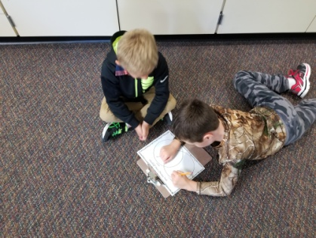
Please remember the pizza fundraiser packets that went home last week. Any student that sells 1 item gets to attend the pizza party.

Second Grade Daily Schedule
(subject to change due to Specials)
8:05-9:00- Math
9:00-10:30- Reading
9:00-9:45- Full Group Reading
9:45-10:30- Small Group Rdg
10:30-10:50- Recess
10:50-11:20- Math Practice/Groups
11:20-11:40- Lunch
11:40-12:30- Language/Writing
12:30-12:50- WIN Groups
12:50-1:20- Writing or Phonics
1:20-1:50- Recess
1:50-2:05- Snack/Read Aloud
2:05-3:00- Science or Social Studies
3:00-3:05- Dismissal

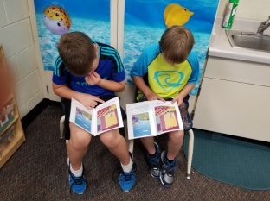
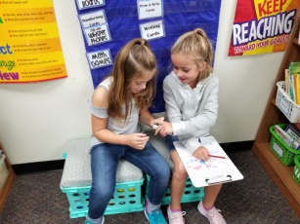
Students work in groups: playing a math game and doing reading practice.

