[bdubord@ncajets.org](mailto:bdubord@ncajets.org) <http://bdubord.weebly.com>

SECOND GRADE NEWS September 22, 2017

**Weekly Notes:**

~ If you have not returned Bookmobile cards, please do so soon.

~Thank you for all the delicious snacks this month! We appreciate it.

~ Remind 101 has been helpful to me for sharing pictures/info, etc. Thanks to all who have signed up. Please let me know if you need me to resend info.

**Reading:** Next week we will be reading Henry and Mudge and the Starry Night. We will be practicing describing the characters and setting based on the story and pictures. This week, we worked on Main Idea. Students worked with a group to determine the main idea of a paragraph. They created a poster and presented their poster to the class. Students did a great job working together in groups. See pictures below.

**Spelling:** Homework next week will be 10 points from the Spelling Contract. Next week’s words will be consonant blends. Words will be: stop, clip, strap, stream, nest, hand, mask, twin, brave, breeze, ask, state, straight, skeleton

**Math:** This week we finished Unit 1 of Jump Math, and we took our test today. Please note that we have been learning different strategies for solving problems. If a certain one does not make sense, do not panic. Students learn a variety of strategies, and I remind them what works best for one student may not be the best strategy for another. Next week starts Unit 2, which starts as a review of using number lines and correctly spelling number words. We will also be forming review groups based on Unit 1 tests.

**Language/Writing:** This week, we really focused on using capital letters and punctuation in our writing. Next week, we will be continuing to write narrative pieces that fit with our reading story of the week: camping and the outdoors. For writing, we will continue working on expanding using details, and rearranging words so the sentence can be written in a different way.

**Science/Social Studies:** We finished our unit on rural, suburban, and urban communities. Students had the chance to brainstorm the type of area they prefer, as well as problems that would come with any type

of community. We will be continuing with Social Studies

next week. We will be learning about how to read a map,

as well as creating maps of our local school community.

On Monday, we worked with Mrs. Veeser’s class to create

a Second Grade Constitution based on things the students

found important. Check out my 2nd Grade website for more

details/pictures! <http://bdubord.weebly.com>

Name: ____________________________________

**Upcoming Dates:**

**September:**

**25th- Elementary Pictures**

**27th- Pizza Sale ENDS**

**Thanks to all who have sold!**

October 13- Early Dismissal @ 12:00

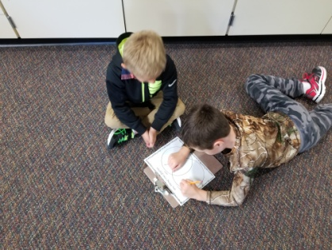

This year, it is important that your child is reading nightly and practicing math facts. A great way to practice at home is the website Xtra math. A letter is going home today with directions on how to login at home. This is a FREE website. We use it in the classroom as well. A student spends 5-10 minutes a session working on increasing speed.  In order to "master" a skill, students must be able to correctly answer each fact within 3 seconds. I get reports that show how your child did. Please let me know if you have any questions!

