SECOND GRADE NEWS

[bdubord@ncajets.org](mailto:bdubord@ncajets.org) bdubord.weebly.com September 27, 2019

**Important Notes:** Today, a Book It Reading Log is going home. Anytime a student reads at home, they can record it on the log by writing the minutes. At the end of the month your child can return the log to me for a free personal pizza from Pizza Hut. Remember: Reading can come in many forms- reading aloud, silent reading, etc.

**Reading:** Next week we will be reading a nonfiction text: *A Walk in the Desert.* We will be discussing main topic, idea, and details. We will also be looking at how the images help us to understand the text.

**Spelling:** Next week’s words will be endings –ing and –ed. We will spend the week reviewing when you double consonants or drop an e. These are tough words for 2nd graders, so any extra practice at home is great! Words will be: dropped, dropping, excited, exciting, lifted, lifting, hugged, hugging, smiling, smiled, talked, talking

**Language/Writing:** This week, we started our Writer’s Workshop where we get in a writing routine with a mini lesson, writing time, and share time. Next week we will start Fall narratives. In Language, we will be focusing on capitalizing holidays, product names, and geographic names.

**Math:** Unit 1 tests will be going home today. We will continue with addition strategies next week. We will be discussing the strategy of making a ten to help us add. We have been practicing what numbers make 10 using different math practice games. Remember, the more students practice their facts, the easier these skills will be. We have been reviewing facts by playing math games. (See pictures on right.)

**Science/Social Studies:** This week we started our map unit. We also learned about Johnny Appleseed by creating a map of where he went and tasting different apples.

**Upcoming Dates:**

**10/3- Mrs. Dubord at ISD with UP Health Project Team- Substitute Teacher in room**

**10/11- 12:00 Dismissal**

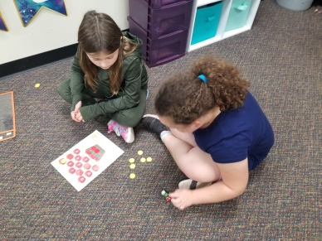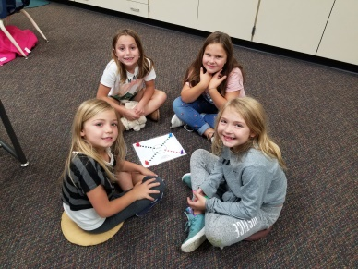

**Next week we will be starting small groups for all students based on what they need to grow. This could be a review of skills or something to challenge them.**

**SEL Skill of Week**

This week we learned about the Platinum Rule- Treat others the way THEY want to be treated. Not every child responds the same (some like to be left alone when upset, some like to be talked to). Next week we will talk about being a responsible student.