SECOND GRADE NEWS

[bdubord@ncajets.org](mailto:bdubord@ncajets.org) bdubord.weebly.com September 6, 2019

**Upcoming Dates:**

**9/6- Pizza Sale STARTS**

**9/12 Book orders due-**

Book Orders went home today. This year, sponsors have donated so each student in our class will be able to choose a free $1 book from each month’s order!

**Important Notes: We had a busy first week of school! We spent a lot of the week doing beginning of the year routines. We will continue this next week. We also talked about “bucket filling” and ways we can be friends to all.**

**\*Please remember to turn in $2 for Activities money if you have not done so.**

**Reading:** Next week we will be reading our first story from our reading series: *Iris and Walter.* It is a fiction story, and we will be focusing on the standards of character and setting.

**Spelling:** Our first week’s words will be short vowels. This year I am not doing any homework. So, you will notice the list going home in the take home folder. Students may practice these at home, but are not required to turn anything in. Please keep the words in the take-home folder so your child has them at school to practice. **Words for the week are: *drum, rock, chop, list, sack, tag, desk, rib, job, mess, sad, dust, pocket, lettuce, engine***

**Language/Writing:** We are reviewing what makes a complete sentence and practicing this skill. We will be discussing writing narrative stories.

**Math:** We started our first Jump Math Unit. The year starts with a basic number sense review, and we will move into even and odd numbers next week.

**Science/Social Studies:** Throughout the year, we rotate between Science and Social Studies. Next week, we will be learning about rural and urban communities. This matches our reading story. I try to make Science hands-on and exciting. I am planning to do some introductory team building challenges in the next few weeks to help prepare us for the group work we do in Science throughout the year.

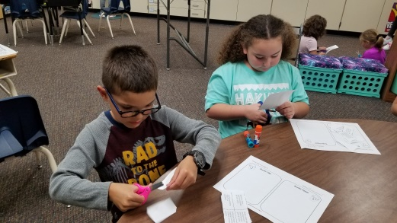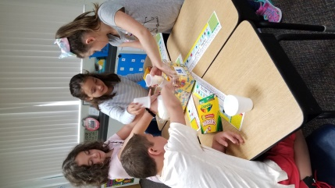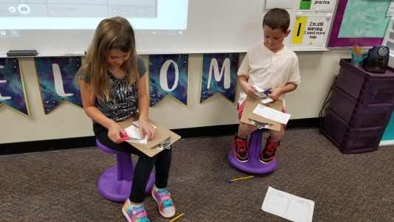

**Specials Schedules**

Monday- Library

Tuesday- P.E. 1:55-2:25

Wednesday- Library or Art 8:05-8:50

Thursday- Music: 1:55-2:25

**Pizza Sale**

The pizza sale starts today! Please consider helping our school! Every student who sells one item can attend the pizza party!